Chizel – The Git We Need
Final Year Project Report
Computer Science
Section: English
Group: B01
Students:
- Student 1 – 60388 – Patrick Farah
- Student 2 – 61116 – Charbel Fares
- Student 3 – 61105 – Bilal Hammoud
- Student 4 – 61102 – Omar Hammoud
Supervisor: Dr. Bernadette Wakim

Table of Contents

1. Introduction 3
2. Bibliography 4
3. Business Rules & Requirements 5
4. Analysis 6
4.1. Use case Diagrams 6
4.2. Class Diagrams 8
4.3. Activity Diagram 10
5. Development 12
5.1. Navigation Structure 13
5.2. Chizel Screens 32
5.3. Backend 45
6. Tasks distribution 46
7. Conclusion 46
8. Appendix 46

Abstract
Nowadays, technological projects require coordination, a key aspect to ensuring a stable workflow especially if the project’s being done by a group of developers, using remote repositories to be able to work efficiently and have the ease of pulling new content into your local machine, allowing users to work on separate details using branches, etc…
However recently, GitHub, the main platform used for these remote repositories, has been barraged by AI Slop, from their own owner no less, Microsoft, pushing the highly debated AI agenda onto the platform, with the full focus on making their AI Agent better, without thinking of the platform and the users themselves.
GitHub suffers from multiple things, one of them being the slowness of some features due to GitHub running some parts on what we call “Spaghetti Code”, a form of code that isn’t optimized as it should be.
We decided that we needed to do something, with Microsoft’s full focus on the unstable AI bubble, we proposed making a GitHub and Git alternative, called Chizel, acting as the replacement of Microsoft’s giant without all the AI and Corporate slop that big companies keep pushing.
To compete with such monster, we decided that it’s best to code the git-alternatives in the same language, C, the most efficient one we can use, prioritizing speed and efficiency for the best quality possible.
What we’ve achieved so far is a is a working git system that’s owned and made by us, called chz, and a website to support this git equipped with a simplistic and straight forwards interface that’s easy to navigate, and a backend to help display the user’s data and make the git actions possible within the website itself.

Introduction
In recent years, software development has increasingly relied on collaborative platforms that enable version control, code sharing, and team coordination. Platforms such as GitHub have become the norm to modern development workflows, providing developers with tools to manage repositories, track issues, and collaborate efficiently. GitHub is the most widely used platform for such activities, however, due to it being owned by a single company, a mistake can be catastrophic, which is what's happening with Microsoft pushing AI and monetization onto this precious platform.
These recent updates brought out wishes among developers for simpler, more transparent alternatives that prioritize control and privacy. Many developers prefer environments that are free from intrusive AI assistance, unnecessary feature bloat, and corporate-driven design decisions. As a result, there is a need for a lightweight and developer-focused platform that retains the essential features of GitHub without the AI and corporate "slop" that's being pushed by Microsoft.
The problem addressed in this project is the lack of a minimal, clean, and independent alternative to GitHub. Existing platforms often impose limitations, introduce complex user interfaces, or integrate features that may not align with all developers’ preferences, particularly those who value simplicity and efficiency.
To address this issue, this project proposes Chizel, a GitHub clone designed to provide core repository management and collaboration features while remaining lightweight and free from unnecessary complexity. The main objective of Chizel is to offer a simple environment where developers can create repositories, manage version control operations, and collaborate with others without the influence of AI systems or excessive corporate features. The system focuses on remaining transparent with it's features by being Open-Sourced for everyone to see.

Bibliography
GitHub and Git are the center of modern software development workflows. GitHub is a cloud-based platform used to store, share, and collaborate on code through repositories, while Git is the distributed version control system underneath it. GitHub’s documentation explains that repositories let developers track changes, review code, and collaborate safely, and Git’s own documentation describes it as a fast, scalable, distributed revision control system. In Git, project history is stored through objects such as blobs, trees, and commits, while branches act as movable pointers to commits, which makes parallel development and merging possible.
From a functional point of view, GitHub works by linking a remote repository with local Git repositories on developers’ machines. Users create branches, make changes locally, push updates to the remote repository, and use pull requests to manage integration and code review. This model is effective because it preserves history, supports collaboration, and allows developers to work independently before merging changes back into the main branch.
GitHub’s main strengths are its ease of collaboration, repository hosting, code review tools, and its ability to support both public and private projects. Git also offers strong branching and merging support, which is one of the reasons it became the standard version control tool in software engineering. However, some developers view GitHub as increasingly complex and more feature-heavy than a minimal repository host. GitHub’s own AI pages show that the platform now puts strong emphasis on Copilot, AI-powered workflows, and agent-based development features, which supports the idea that the product direction has expanded far beyond simple hosting and version control. In a report, this criticism should be phrased carefully as a user perspective or limitation, not as an absolute fact.
GitHub has also faced public controversy. Reporting from major outlets showed employee protests over GitHub’s contract with U.S. Immigration and Customs Enforcement (ICE), with workers demanding that the company end the relationship, while the company said it was not reconsidering government contracts. That controversy is useful in a Chizel report because it supports the argument that some developers want platforms that feel more independent, privacy-conscious, and less shaped by corporate decisions.
For Chizel, the gap between what already exists and itself, is that these current platforms are powerful but heavy, increasingly AI-driven, and not always centered on simplicity or privacy. This is where Chizel comes in to be the lighter version, with it’s simple UI, and non-invasive features like AI Agents, which often imposes limitations to drive people into their monetization schemes.
Chizel can be positioned as a response to those limitations. The project focuses on simplicity, privacy, and core repository features rather than unnecessary complexity. It aims to keep the essential GitHub-like workflow, such as repository management, collaboration, and version tracking, while leaving room for future expansion without forcing users into an overly corporate or AI-centered experience. That makes Chizel relevant as a cleaner alternative for developers who want the fundamentals without the extra noise.

Business Rules & Requirements
The key objectives of the project include:
- Designing a clean and simple user interface for repository management
- Implementing essential version control features such as commits, branches, and pull requests
- Enabling collaboration between users through repository sharing and contributions
- Ensuring smooth system performance
- Maintaining simplicity by avoiding unnecessary or intrusive features.

The scope of the project is limited to the development of a web-based platform that supports core functionalities similar to those found in GitHub. This includes repository creation, version tracking, and basic collaboration tools. However, the system does not aim to replicate all advanced features of GitHub.
Limitations of the project include the absence of free time, due to being overwhelmed by the sheer amount of work to be done, and sticking to our morals by not using any AI tools, and impending doom next door, we try to work as much as possible with the time we have available. Additionally, we lack the important resources to implement features beyond what our original scope offers.
This project is conducted as an academic initiative and is not affiliated with any company.

Links and Documentations used:
Posix: https://0x04.net/doc/posix/O'Reilly%20-%20POSIX%20Programmer's%20Guide%20-%20Writing%20Portable%20UNIX%20Programs%20with%20the%20POSIX.1%20Standard%20-%201994%20-%20(By%20Laxxuss).pdf
C reference:
https://en.cppreference.com/c/language
Git documentation:
https://git-scm.com/docs
Express JS documentation:
https://expressjs.com/
React features:
https://www.youtube.com/watch?v=6UU2Ey4KZr8
C Headers and Functions:
https://pubs.opengroup.org/onlinepubs/007908799/index.html
PostGreSQL:
https://www.postgresql.org/docs/current/libpq.html
SupaBase:
https://www.instagram.com/supabasecom
SHA1 and SHA256:

Analysis

Use case Diagrams
The system should be able to:
- Allow users to register and log into accounts
- Allow users to make repositories, visit/view repositories and contribute to repositories
- Allow users to clone repositories
- Allow users to initialize a chz directory
- Allow users to upload and manage files directly to the remote directory
- Allow users to commit changes
- Allow users to create branches
- Allow users to push data/changes from local to remote, and pull commits from remote to local
- Allow users to create/manage pull requests
- Allow users to see commit/versions history (version control)
Also, the platform itself should:
- Have fast response time
- Be up to security standards
- Have clean and simple working UI
- Support multiple users
Here’s what the use case diagrams look like, alongside some scenarios:
Scenarios:
Chz Init Command:
- Name: Init
- Actors: User
- Pre-Condition: directory is not a chz directory
- Description: check the directory current for a .chz directory
Scenario 1: .chz directory already exists and the init fails
Scenario 2: chz creates a .chz directory with all required folders and files to operate
- Post-Condition: initialize the directory into a chz directory
Chz Branch Command:
- Name: Branch
- Actors: User
- Pre-Condition: User’s working directory is a chz directory
- Description:
  - User creates a new branch and gives it a name
  - Operation succeeds or cancels if duplication is found
- Post-Condition: New branch reference head file is created
Chz Merge Command:
- Name: Merge
- Actors: User
- Pre-Condition: At least two branches exist in the repository
- Description:
- User selects a branch and merges with the main branch
- Does conflict checks in case of matching file names
- Cancels merge process by notifying the user of conflict files
- Post-Condition: specified branch is merged into current branch
Chz Fetch Command:
- Name: Fetch
- Actors: User
- Pre-Condition: User has at least one git repository
- Description: user connects to a remote repository using the URL or SSH
git scans the fetches the commits within the repository
- Post-Condition: git downloads the commits to the local repository as a separate branch without merging it into the local branch
Chz Checkout Command:
- Name: Checkout
- Actors: User
- Pre-Condition: there exist at least 2 branches on a repository where the user is owner ot contributor
- Description:
- User inputs commnd with a branch name
- system validates given branch exists then switch to it if branch doesnt exist give error
- user may pass the -b flag to instead create a new branch if the given branch doesnt exist
- Post-Condition: current branch is set to specified branch
Chz Add Command:
- Name: Add
- Actors: User
- Pre-Condition: User has at least one git repository
- Description: user specifies the file or files to be added
(User can specify one file by specifying its name,
user can specify a list of files to be staged,
user can add all files in the directory by appending “x.” to the command)

- Post-Condition: the specified file(s) are added to the staging area
Chz Push Command:
- Name: Push
- Actors: User
- Pre-Condition: User has a local repository equipped with an origin, while being a contributor to the remote repository
- Description: Creates a new commit then uploads compressed local data to the database, altering the remote database
Scenario 1: Successful Push
Scenario 2: Non-Pass-Forward, push gets rejected because the local branch is behind the remote branch.
Scenario 3: Failed Authentication, push gets rejected because the user failed to provide the required authentication to access the remote branch.
Scenario 4: New branch push, user pushes a branch that doesn’t exist on the remote repository.
- Post-Condition: User successfully uploads new data to the repository’s database fields
Chz Commit Command:
- Name: Commit
- Actors: User
- Pre-Condition: User has at least one git repository, user has uncommitted changes in the staging area.
- Description:
git asks the user for a commit message
git checks the staging area for changes to commit to the local repository
git creates a new commit object in the local repository, related to the current branch
- Post-Condition: commit staged changes to the local repository
Chz Status Command:
- Name: Status
- Actors: User
- Pre-Condition: user owns or contributes to atleast one repository
- Description:
- Shows staged changes in a list
- Shows non-staged changes (modified or untracked) in a separate list
- various flags control how much info is displayed
- Post-Condition: display some status info of current branch
Chz Pull Command:
- Name: Pull
- Actors: User
- Pre-Condition: User either owns a remote repository or is a contributor to one
- Description: User requests to pull from a remote repository, which will perform chz fetch & chz merge
- Post-Condition: chz merges the fetched data into the local repository
Chz Clone Command:
- Name: Clone
- Actors: Owner, Guest, Contributor
- Pre-Condition: Owner, Guest or Contributor is registered and has access to the remote repository to be cloned
- Description: user either uses the remote repository URL or SSH to access the repository.
Git fetches all the files within the remote repository to be cloned to the local repository.
- Post-Condition: creates a repository based on another (usually remote) repository
Chz Tag Command:
- Name: tag
- Actors: user
- Pre-condition: user owns or contributes to atleast one repository
- Description:
- Scenario 1: Creates a static snapshot of the current branch at the time of tag creation
- Scenario 2: Creates a static snapshot of the current branch at the time of tag creation additionally stores extra information like date of creation
- Scenario 3: delete given tag if exists
- Scenario 4: reads given tag
- Post-condition:
- Scenario 1: creates light tag after given name
- Scenario 2: creates heavy tag after given name
- Scenario 3: display report or error message incase of success or failure
- Scenario 4: display given tag information
Chz Log Command:
- Name: Log
- Actors: User
- Pre-Condition: User has at least one git repository, repository has at least one or more commits
- Description: returns log entries based on the selected mode or specified branch
Post-Condition: display commits history alongside author, hashes, date & message
~ 1.1: We categorize Chizel’s abilities into 4 parts.
- Repository features such as viewing repositories and logs, pulling from and pushing to repositories, creating and deleting repositories.
- Branch features such as creating, deleting, merging, viewing and renaming branches, staging and committing changes.
- Account features such as registration, log in and log out.
- Pull Request features such as creating, viewing, submitting, approving and denying pull requests to the repository.
~ 1.2: Here we divided the chz commands that will be available (hopefully) at release, containing the main branch and commit features, while also having some extra commands for the sake of not being lackluster.
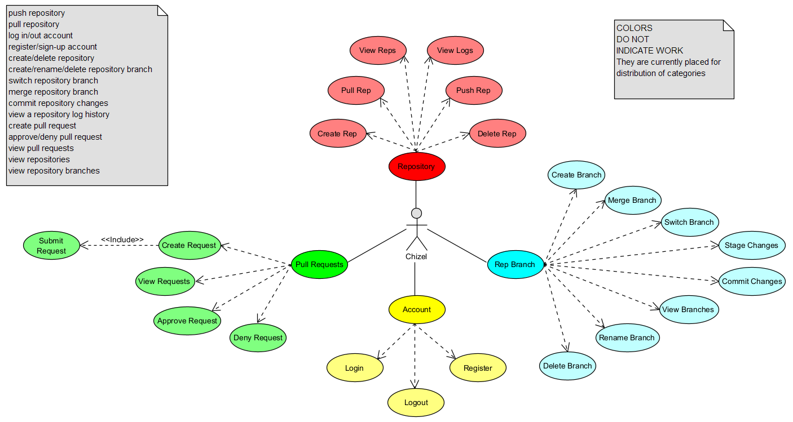
1.1: Chizel Use Cases.
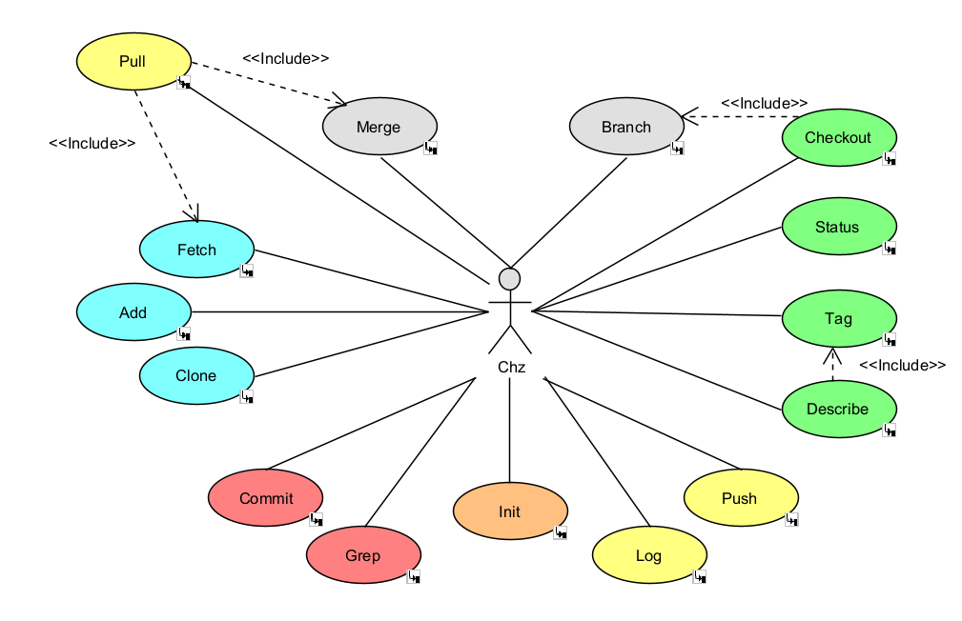
1.2: chz Use Cases.

Class Diagrams
Alongside our Use Case diagrams, we have come up with a Class Diagram:
The class diagram is a 1:1 replica of the current database schema. It features:
- 2 enums specifically for pull requests
- An account class, holding every bit of critical info & customisation for each user
- A repository class, reflecting the important information about each repository
- A repository metrics class, which holds the extra non-important statistics of the repository its linked to
- 3 account-repository class links, corrolates to which repositories an account has starred, watched or is a contributor towards
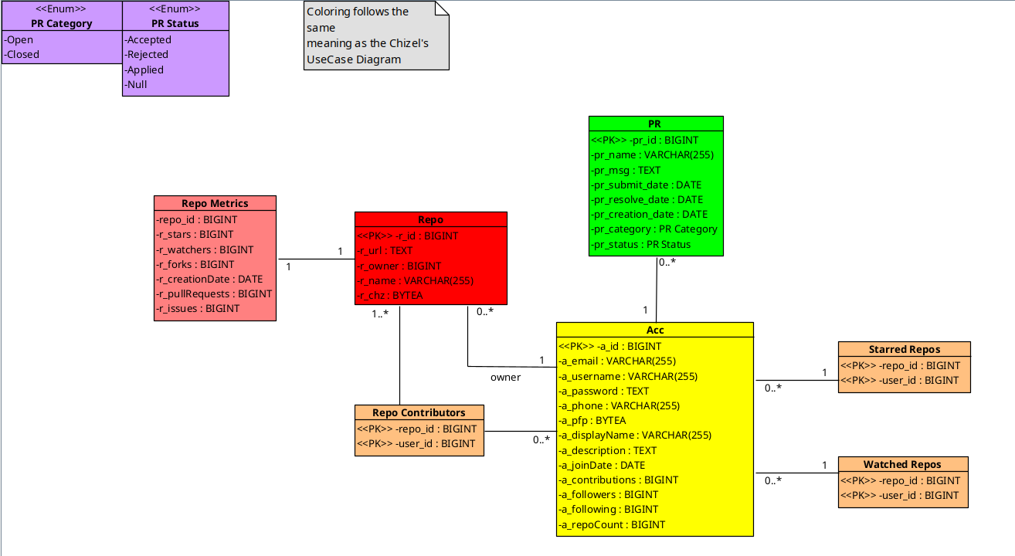2.1: Current Class Diagram

Activity Diagram
We’ve also made an Activity Diagram showcasing how chz workflow works:
The activity diagram shows us where the flow of chz travels once it’s called, when someone uses any chz command in their terminal, the flow starts, and immediately checks the last argument given, if it’s the “-h” flag, the program displays how to use the command of the function by looking at the argument before it, for example “chz clone -h” gives help to work with clone, the 2nd command it checks after init, since both are the only commands that don’t require an initialized .chz directory to work, if it isn’t either of these 2, the flows goes on and checks the other commands for a match, in which it eventually fails if the commands is faulty or doesn’t exist. In the case of the command actually being found, the flow goes on and directs data through the functions of the command to achieve it’s goal before ultimately terminating with a success or a fail depending on the situation (faulty args, errors while input, bugs).
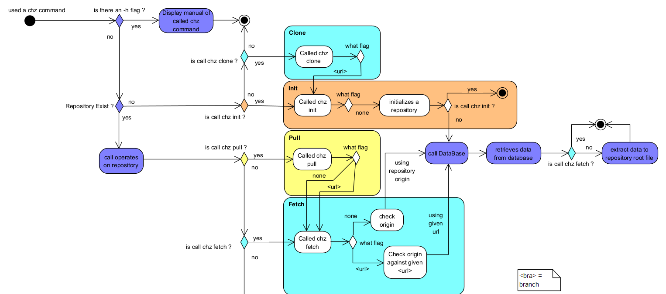
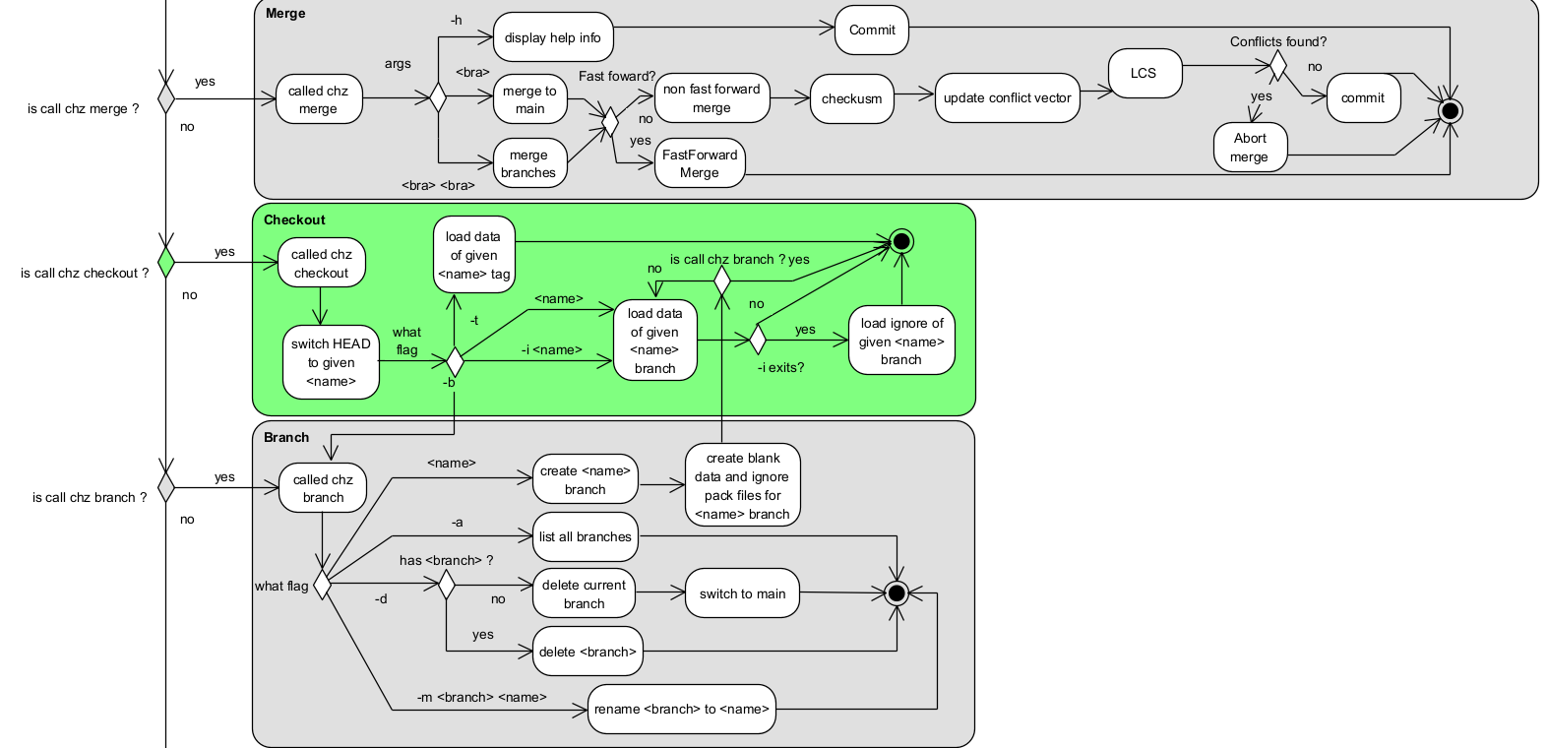
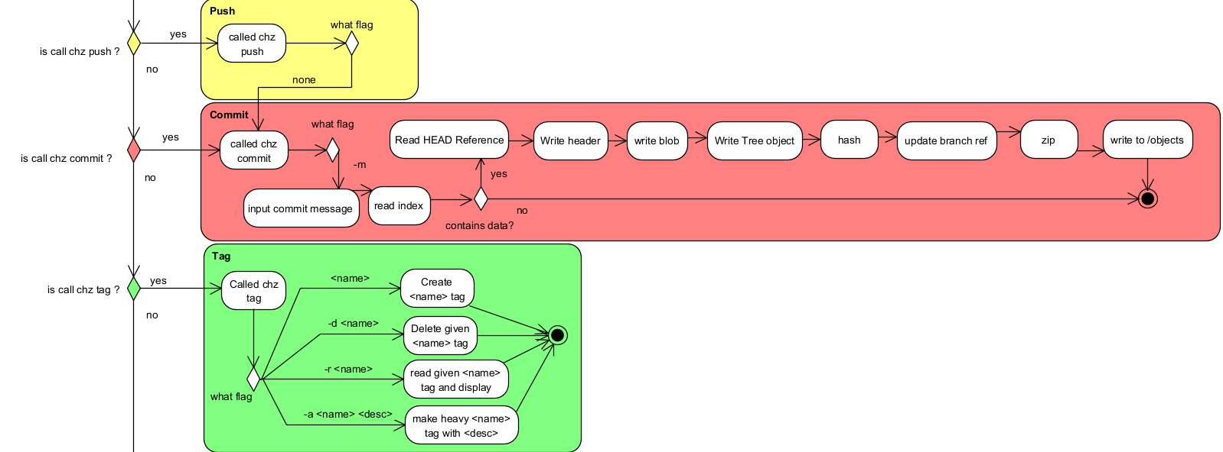
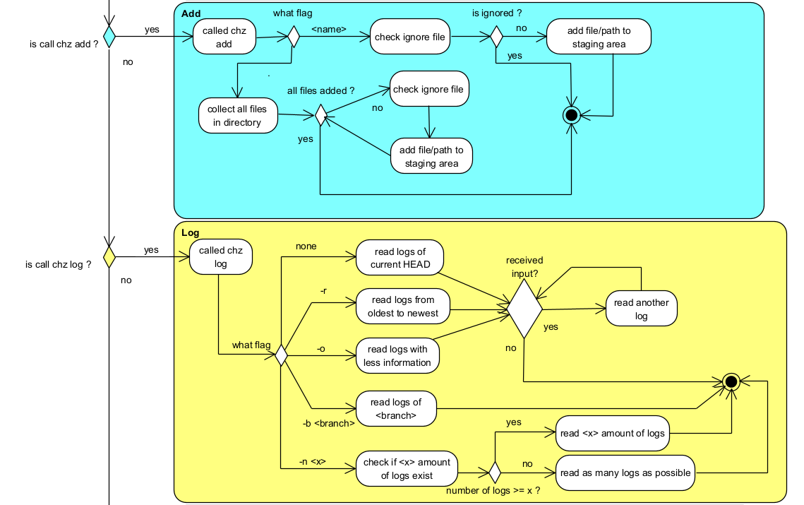
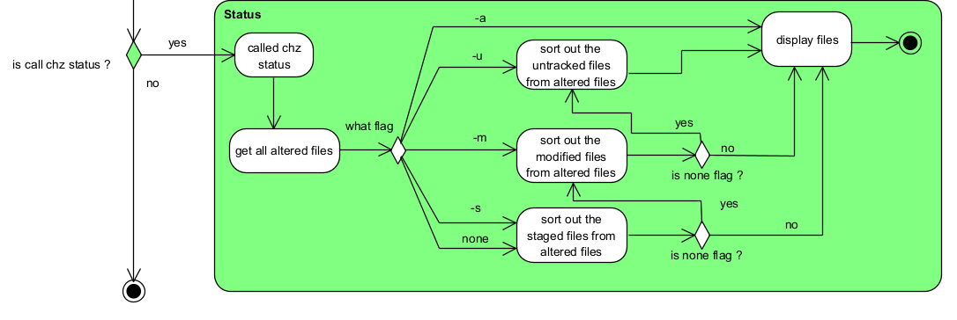

Development
In order to make Chizel a competitor to GitHub, we have to one up it somehow, starting by using the same language for its commands, C, as it’s the most efficient and the fastest in this domain, alongside that, we’ve used TypeScript and React to make the interface, all thanks to Figma which made our work 10x easier, with the aid of numerous libraries such as zlib.h, postgresql, dirent.h, and ctype.h, we’ve also chosen Supabase as our database host, for it has proven reliable in multiple other projects, alongside it’s compatibility with C, we’re also ironically using GitHub for our remote repository for easy collaborative work, Visual Paradigm for UMLs, and of course IDEs for coding, starring Visual Studio Code for it’s Live Share Extension alongside an active Discord server for efficient communication.

Here is how the navigation system goes for our platform:

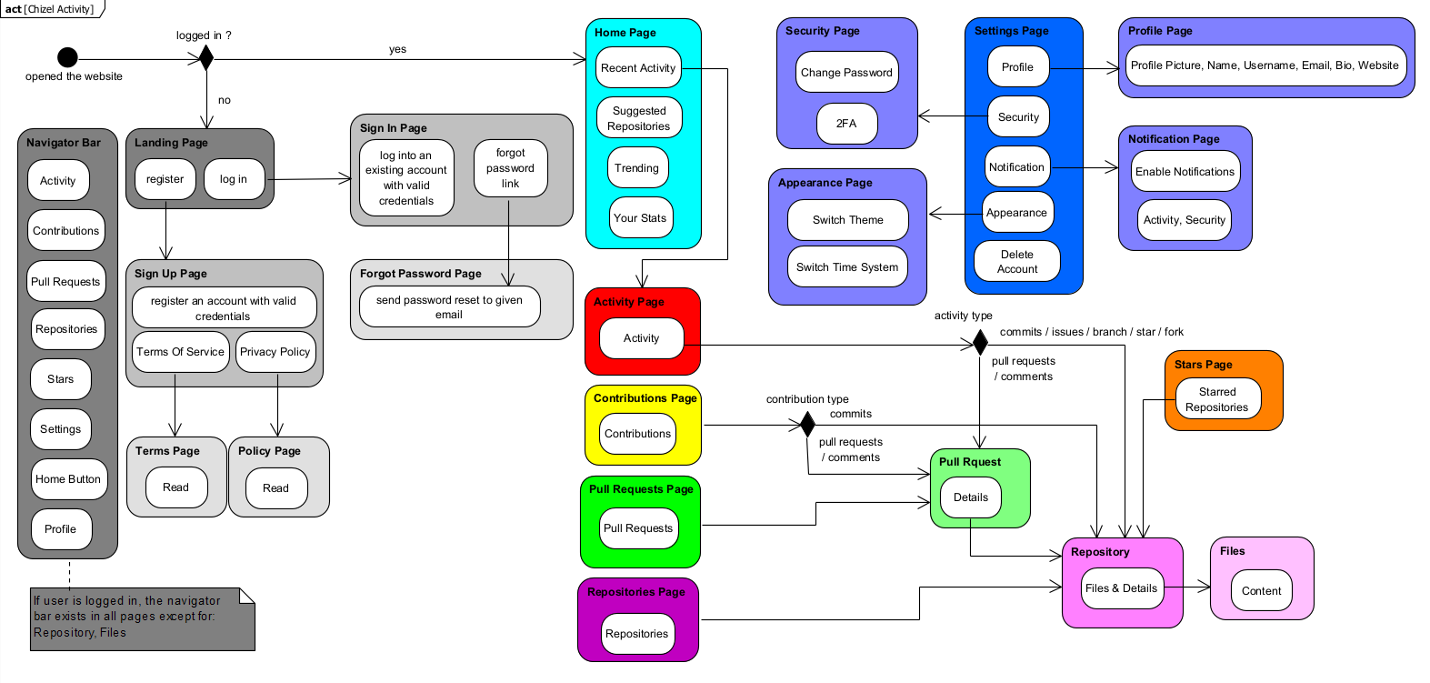

Navigation Structure
We’re able to access multiple other pages from the Home Page, we’re able to log into an account or register one if needed, access our feed which shows the activity of who the user follows, while also receiving notifications from his repositories, which the user can access from the repositories list, and going deeper into a repository, users can also access settings and profile pages for customization and security.
CHZ SCREENS
0.1: The chz init command is responsible for preparing a directory to function as a Chz repository.
It initializes the structure required for chz operations like chz add, chz fetch, chz status and more.
when executed "chz init" creates a hidden directory in the project root. This directory will act as the heart of the system and it stores all repository related data including commits, metadata and branches...
One of the primary components primary components of the chz init is the index file also known as the staging area which will be elaborated on more in the description for chz add, in short it allows users to control exactly what modifications are recorded.
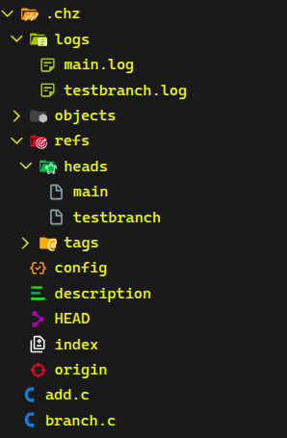

0.2: A small picture showing where and how branches are stored.
The chz branch command allows creating, renaming and deleting branches. Upon creation, a reference head named after the branch is created in the hidden directory .chz/refs/heads, this reference head file houses the commit hash of the latest commit done to the HEAD branch (most cases, its main), this signals that the new branch wields the same data as the latest version of the HEAD on the date of creation, further commits to the HEAD branch will not alter the branch’s commit hash nor vise versa.
Alongside the reference head, a new log file named after the branch is also created in .chz/logs, this stores the commit history of the branch EXCLUDING the initialization of said branch. Renaming/deleting a branch via “chz branch” will affect both reference head and log file.
The command also prohibits any use of “main” as means of deletion, creation or manipulation. In case the current HEAD is a branch that gets renamed/deleted, the HEAD will point back to main in case of deletion, or to the renamed branch otherwise.
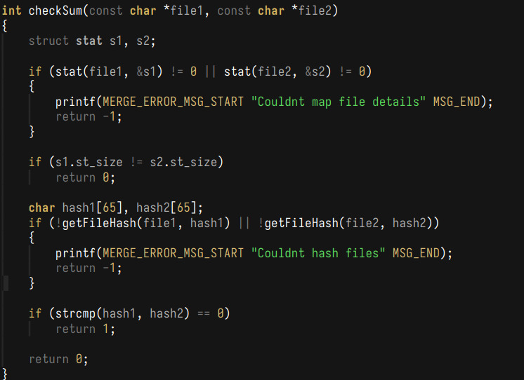
0.3: Merging is a key command in the system.
it allows two branches to be integrated into one, sharing their metadata and their commit history and furethermore is grants "pull" the ability to merge remote changes into a local repository and vice versa. though it seems simple the process is a lot more complex than it seems. I'll be covering the algorithmic side of things.
- Merging requires no conflicts between both branches. which means two branches cannot operate on a same line in a same file but if we were to LCS every file in both our branches we'd be left with a system that leaves no room for efficiency which leads us to two simple but clever optimizations to check for conflicts.
- first, we check file sizes for files with the same name. different side files have to be different, then we use SHA256 to hash files that share the same name and size the uniqueness of hashes ensures that even the slightest changes in a file would yield a totally different hash, an optimization that turns detecting changes from an O(n x m) operation to an O(1) operation.
- once the scan is done, files that have been found to have potential conflicts are pushed to a "conflict vector", now that the margin is much smaller to scan, we can safely LCS over each file pair in the conflict vector to detect any potential conflicts. files that are deemed safe to merge are popped out of the vector, before moving on to scanning the next file pair. if one conflict is detected, the merging operation is terminated though the scanning continues to list every merge conflict found for users to fix.
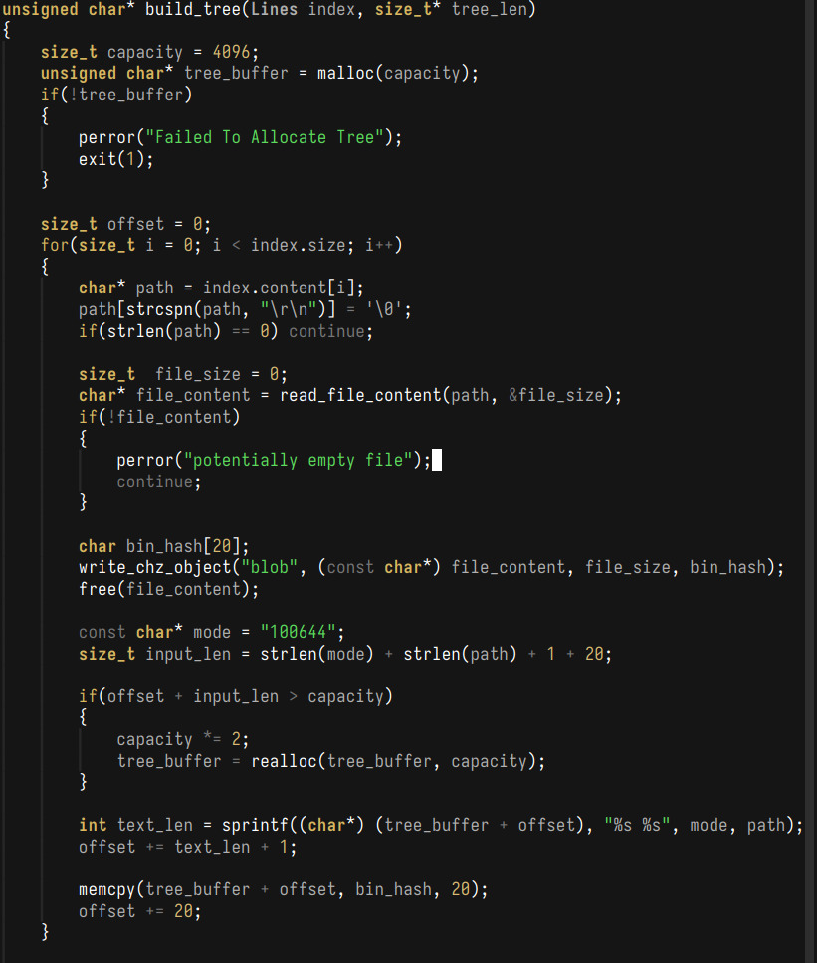
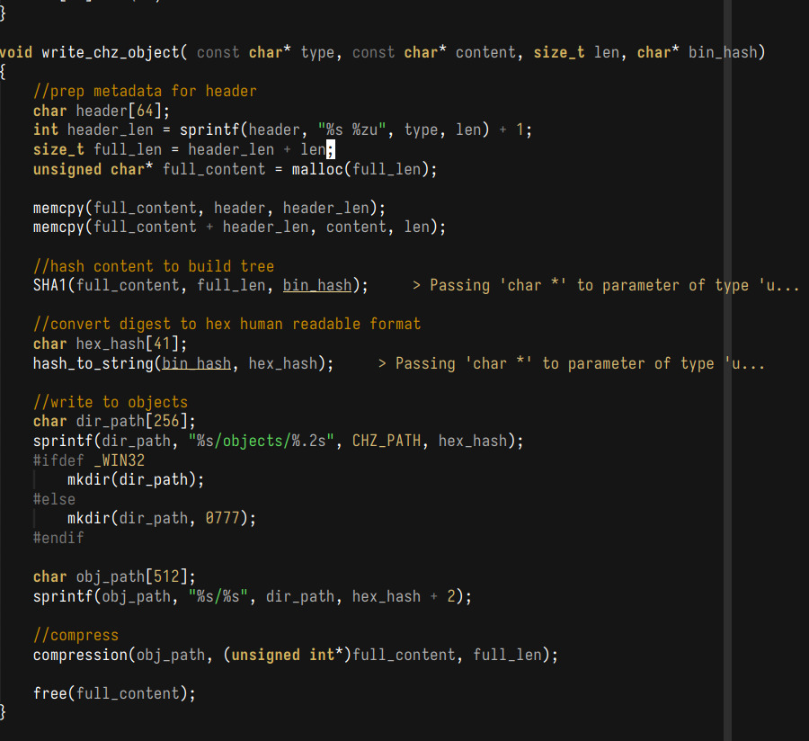
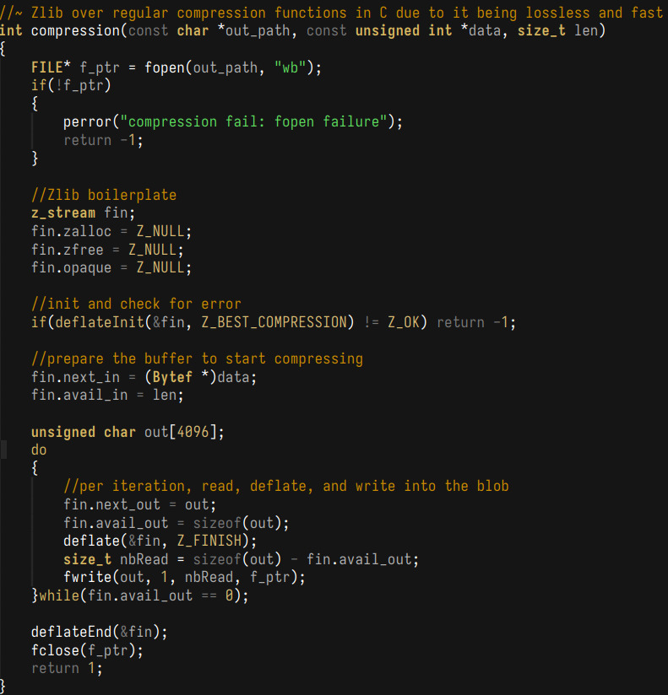
N.B: It's often better to abort merging and have users fix the conflicts themselves for safe and integral concerns.
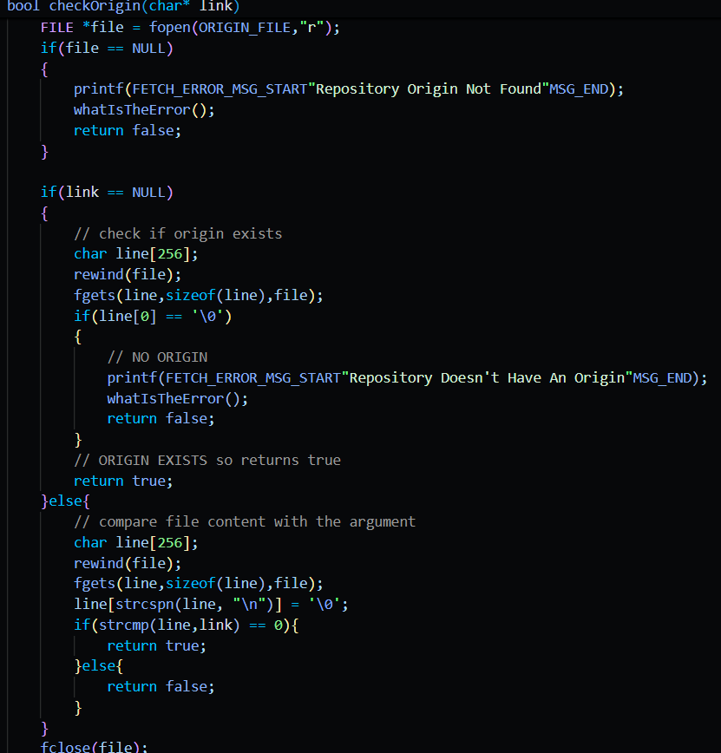
0.4: A snippet of code inside the chz fetch function, showcasing fetch checking the origin of the repository.
The function itself supports 3 flags, a -h helper flag, a flag with no flags, where the function goes and checks the origin file of the repository inside the .chz directory, where each repository receives this file once they go remote and hence acts as the unique identifier for our database, and a flag with a <url> to a remote repository, where the function then checks if the origins match, and depending on the result, outcome changes, if repository doesn’t have an origin, the url becomes the origin, if origin and url match, fetch works normally, and fails otherwise (mismatched origins).
Fetch then takes the origin (or url) and goes to the database, does a query and gets a .pack file, renames it to pulled.pack, and puts it in a specific directory for other functions to use.
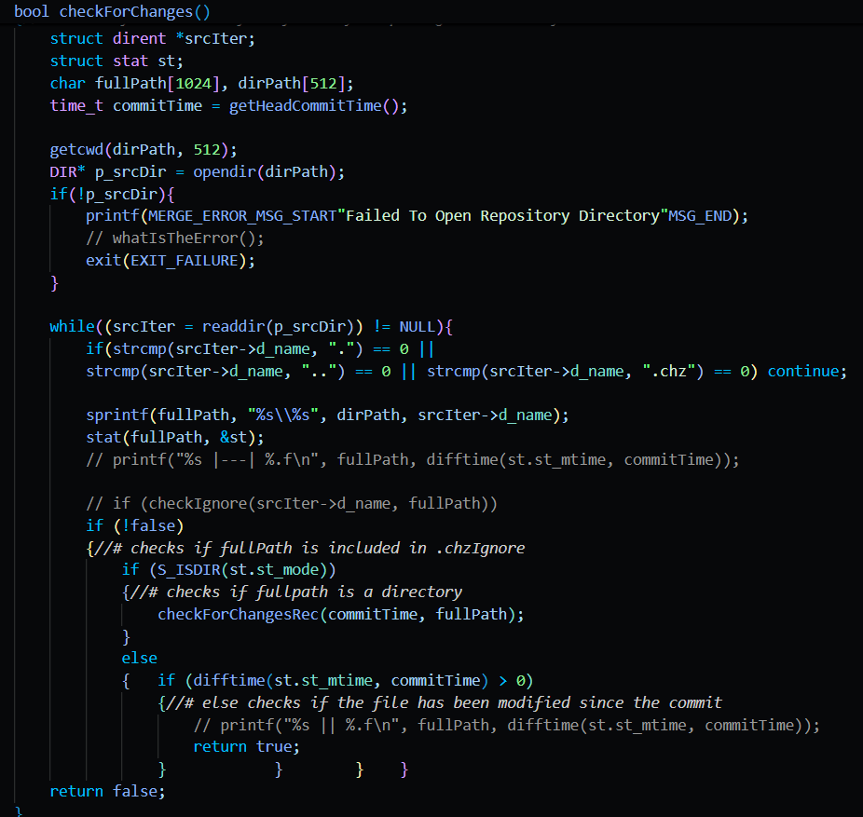
0.5: a code snippet from checkout.c showcasing one of the many functions used to check for a certain condition.
As the name of the function implies this function checks for changed files within the repository. The intention behind this function is to insure that we aren't checking-out of the current branch while there are still un-committed changes to the repository. this is achieved by comparing the repository files modified time statistic value with that of the head commit of the current branch, as when a commit is made to a branch it is there after never modified by anything so the commits modified time statistic value may act as an indicator for if a file was modified before or after the commit has been done.
Additionally this function has recursive capabilities to ensure it can test any files stored within directories regardless of depth.
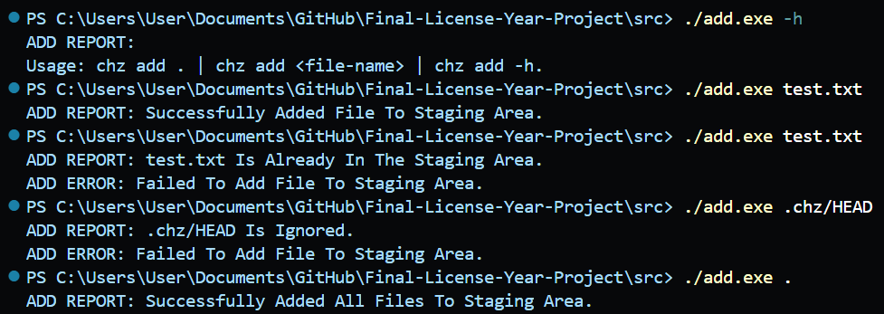
0.6: the add.c terminal with it’s functions
Usable functions include the help function, adding a singular file while also not allowing for duplicates (writing relative path in INDEX file), checks for ignored files in the .chzignore file, works with directories, paths, file extensions and names, and an add all ( . ) function that adds all files that are changed and aren’t ignored to the staging area.
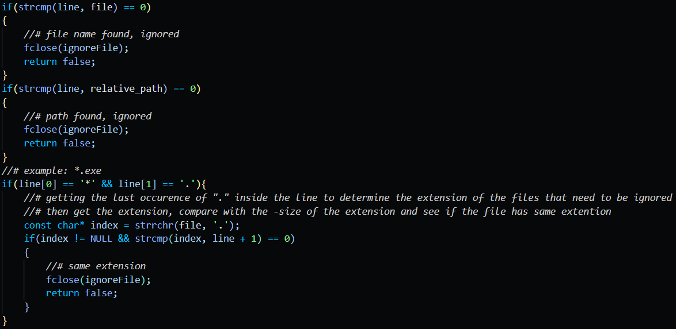
0.6a: a snippet of code showcasing how the ignore function checks the files to be added.
There are many ways files can be ignore, either the direct names of the files (with extensions), or relative paths of complete directories someone might want to leave out (for example .chz/) or even file extensions, that can be detected by finding the last instance of the “ . “ in both the line and file (line from reading ignore file), getting the extension from the ignore file, and then compare the last n characters of the file and line read (n is size of the extension of the ignore extensions).
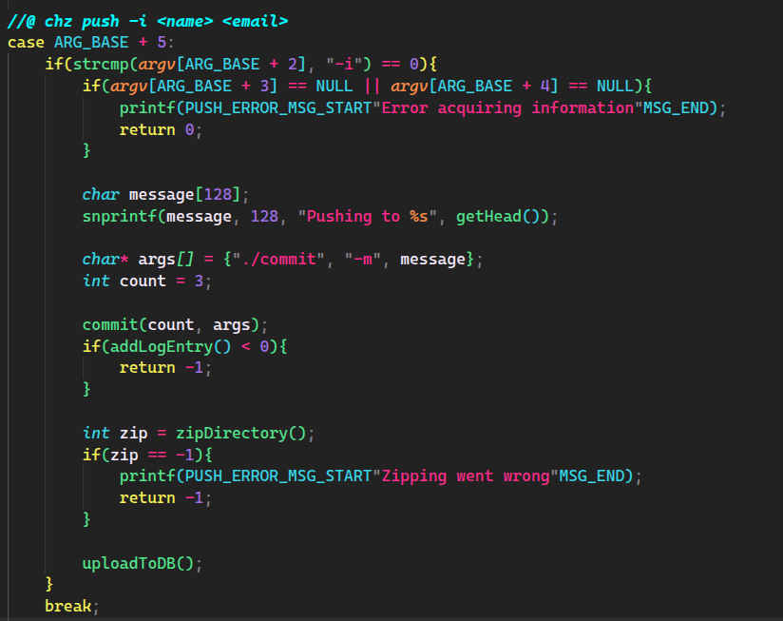
0.7: A code snippet that shows how chz push functions (calls).
Firstly, chz push fabricates arguments and calls chz commit, which does its describe job whilst setting the commit message as “Pushing to <HEAD Branch>” then immediately makes a call to a function of chz log, known as addLogEntry(), which uses commit methods to add a new line to the HEAD branch’s log file with the specified commit information.
Then the packing process starts, the zipDirectory() function, as well as the numerous others it uses, recursively reads & stores metadata of directories & files in the working directory, appending them all to a blob object called “blobs.pack” that resides in .chz/objects/compressed. Once everything is packed into this blob, the uploadToDB() function is called, which fills the necessary information by itself, like the repository’s URL & name, then uploads these 2 fields alongside the blobs.pack file to the database.
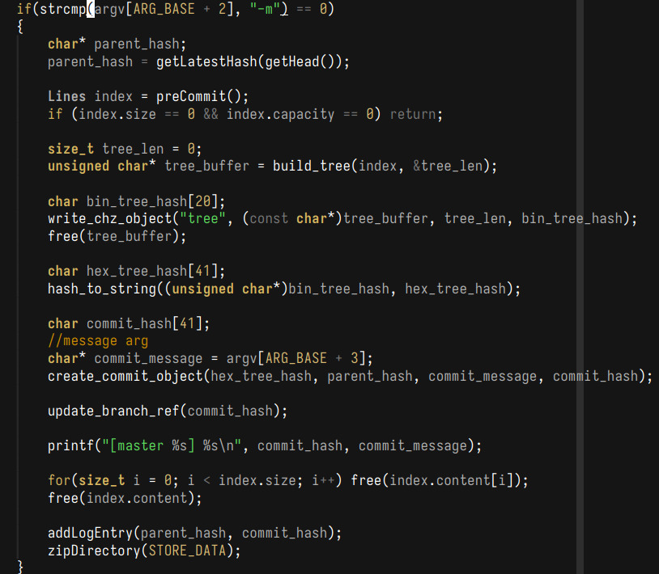
0.8: Committing is a core function of version control systems.
It allows us to take snapshots of our current repository which grants us the ability to rollback on changes. while also acting as a mean to reconstruct a repository to a remote database in a compressed and efficient manner.
Each commit creates a new commit object, which are composed of, headers, tree objects and blob objects. Tree ojects define the structure of a commit, blob objects hold the data and commit objects link it all together by containing both + a commit header which holds metadata about a commit.
The way this is all works together starts by reading the HEAD file to determine the current branch. which is followed by reading the index (staging area) file which holds a list of file to be committed, the latter is hashed using SHA1. using the translated digest we create our tree object, by first creating appending the mode to the start of the line "100644" for directories and "040000" for files, later appending to that mode the first two characters of the digest, which will act as a directory holding the commit object, and the other thirty-eight act as a name for that given object.
Once a commit has its hash, it stores in the header the hash of the commit that came before it, the "parent" hash which is found through the reference in the branch reference, each commit updates the reference in branch so that the next commit can assign the correct commit as its parent which allows us to conserve the history of the repository.
After all the metadata is stored, fetched and hashed, a commit runs through a zlib compression which is a data compression format that uses a deflate algorithms. compressing the objects makes disk operations faster and more space efficient.
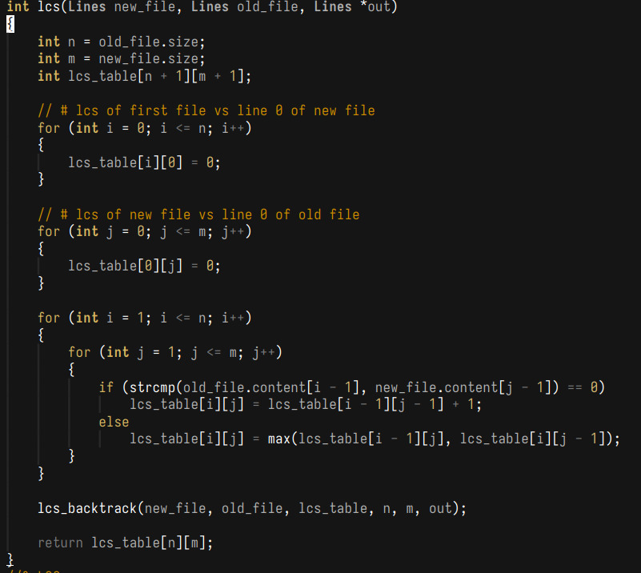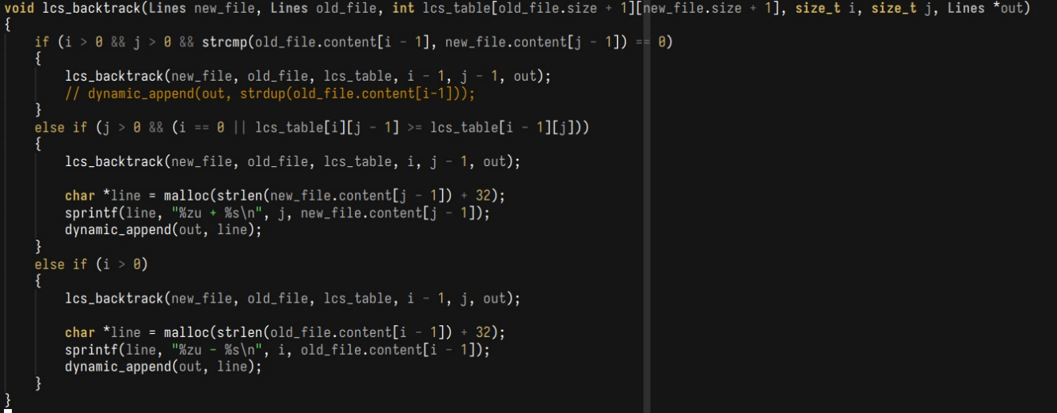
0.8a: The Longest Common Subsequence algorithm is a dynamic programming algorithm that finds the length of the longest common subsequence (LCS);
it's often used to find the LCS between two given strings by recursively walking back from the end of a string and trimming off matching components from both string when no matching component is found and increasing the length counter while recurring to the remaining substring each time a match is found.
Now, you might wonder how this would be useful in a scenario where we are comparing two files. with multiple lines in that.
The answer to that is to modify the LCS algorithm to do the following:
We first shift from characters in strings to lines in a file; we compare two arrays of strings A and B where each element is a line of text. Matches occur only when two lines fully match. And finally, in dynamic programming functions, we use something called a dynamic programming table. A 2D array of size N + 1 and M + 1, with each cell holding the length of an LCS between two indexes.
We finally use this table to backtrack from the bottom-right corner. and we traverse diagonally if we detect a match, up if we find an insertion, and down if we find a deletion.
The reason LCS was used instead of just comparing files line by line is simply because the following would crack under many test cases, like adding a new line at the start. Causing it to catch n-1 insertions instead, line-by-line comparison also suffers from an "offset" issue, where the files have to be perfectly aligned to scan correctly, making it unusable and unsafe for the current use case.
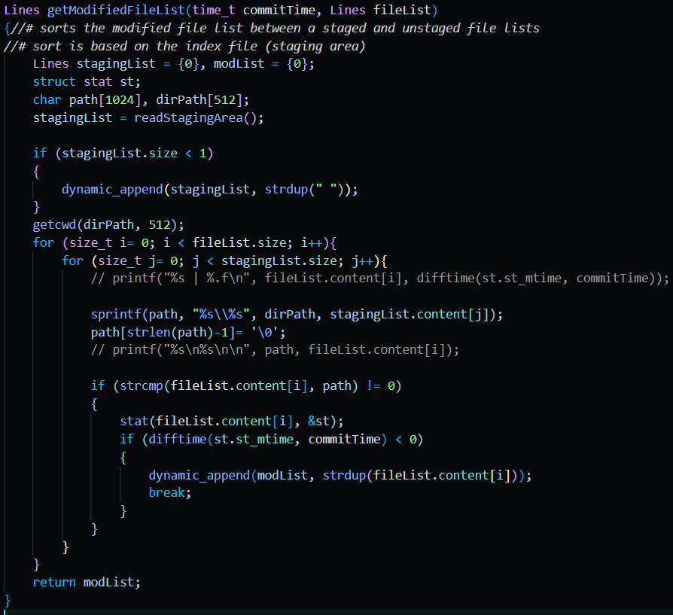
0.9: a code snippet from status.c showcasing one of three functions tasked with filtering a given [fileList] argument into a particular category.
The one above is the function that filters the [fileList] based on whether the given file has not been staged and is not a file created after the last commit as those would place the file under the category of a staged file or an untracked file resp.

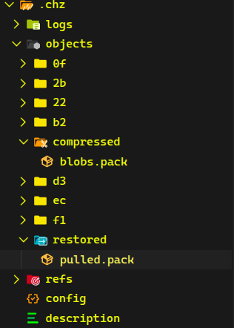
0.10: The image above focuses on the objects folder of .chz, which holds the commit objects, push’s compressed blobs.pack and pull’s restored pack.
The chz pull command calls chz fetch, which stores the data from the database in objects/restored as pulled.pack. After successful fetching of data, pull then calls chz merge which handles how data is inflated into the working directory.
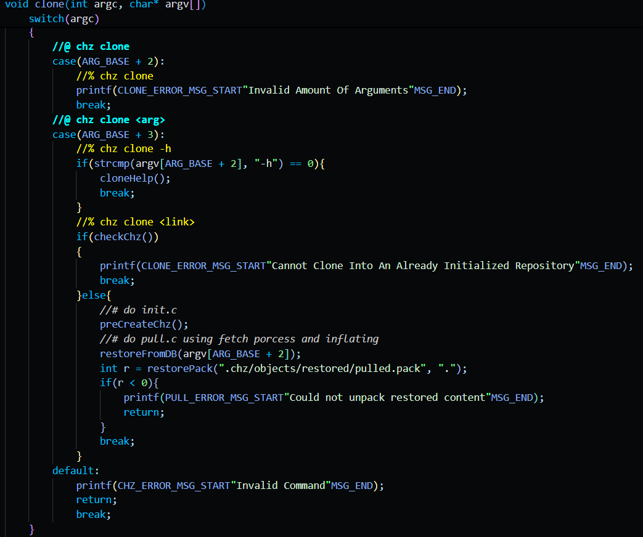
0.11: the entire clone function,
A genius way to re-use already existing functions instead of making completely new ones, this command requires that the current repository isn’t an initialized .chz, because just like git clone, chz clone initializes the repository by calling the creation function from chz init, then accesses the database and uses the fetch function to obtain and unpack the data of the given remote repository’s url directly into your working directory.

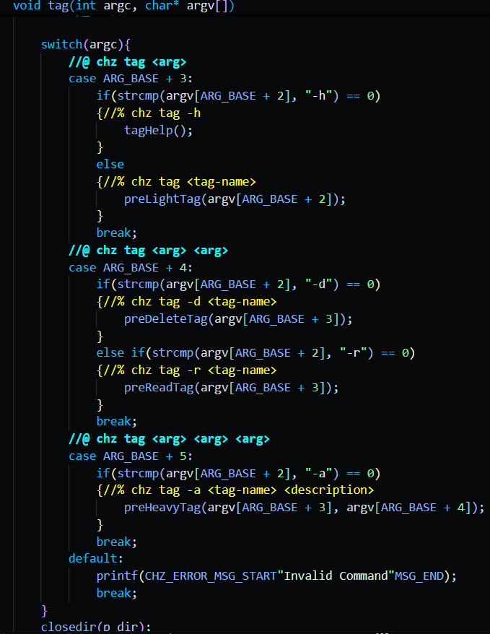
0.12: a code snippet from tag.c that showcases the function responsible for determining what flags have been when calling chz tag.
From the first case, "-h" flag that displays the help page of the command, to many other flags among of which take arguments.
Like the second case "[tag-name]" is used to call chz tag to create a light tag that is named after the given [tag-name], so long as that no tag already exists with that [name]. (light tags are tags that only hold two attributes: a unique [name] and a commit hash)
Then the case, "-d [tag-name]" is used to delete the given [tag-name] tag so long as it exists.
Next is the case "-r [tag-name]" which is used to read and display the given [tag-name] tag to screen if it exists
Finally the case "-a [tag-name] [description]" is used to call chz tag to create a heavy tag that is named after the given [tag-name] tag so long as that tag doesn't already exist. heavy tags are characterized by possessing the same and more fields than a light tag this includes: a unique [name], a commit hash, the date the heavy tag was created, the user that created this heavy tag and a [description] to this heavy tag.
Any other arguments given shall trigger the display of a universal error message informing the user of an "Invalid Command".
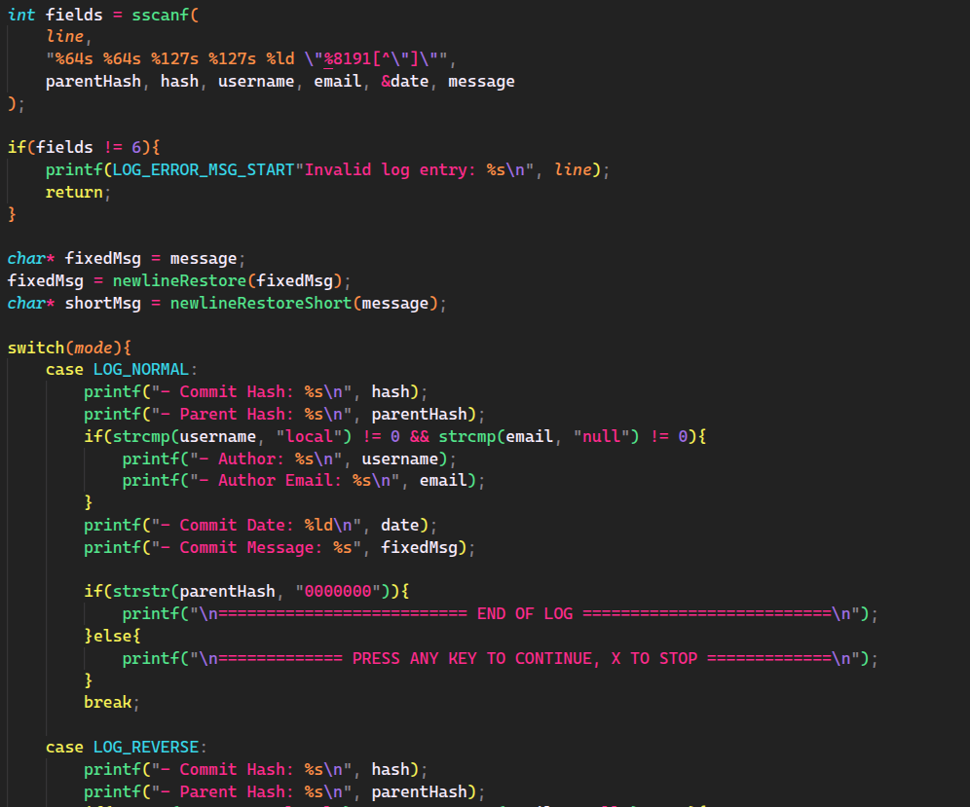
0.13: A code snippet showing how logs are printed to the terminal.
The chz log command has various modes, showcased by the 4 different modes present in the printEntry() function (NORMAL, REVERSE, SHORT, NUMBERED). Each mode changes how and what the function prints. NORMAL and REVERSE both print the full entry details, and both await input from the user for continuation, or simply ends if the entirety of the logs have been printed, REVERSE reads the older commits first. NUMBERED does the same as NORMAL, but prints the user’s requested amount simultaneously without input. SHORT only prints the first 6 letters of both commit hash and parent hash and the first line (or title) of the commit, it has the same functional controls as NORMAL and REVERSE.

Chizel Screens
NOTE THAT SOME PAGES MIGHT BE SHRUNK TO FIT A SCREENSHOT AND ARE NOT BE THE ACTUAL REPRESENTATION, DISPLAYED DATA IS FOR REPORT PURPOSES, ACTUAL DATA IS DIRECTLY TIED TO USER ACCOUNTS.
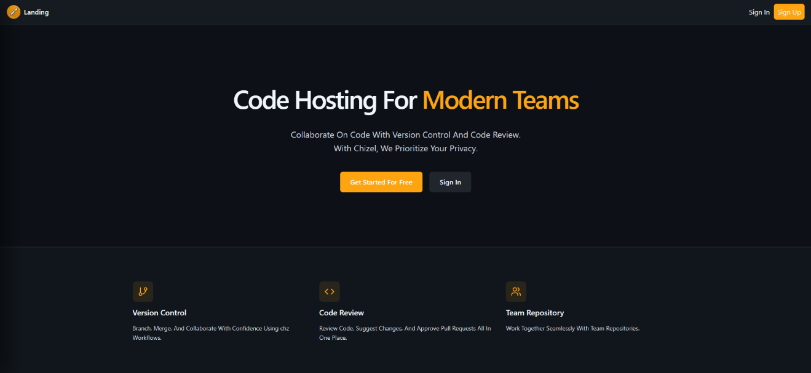
Landing page: when a user first visits the website or is not logged into an account, this is the “welcoming” page that appears, prompting the user to either log in or register an account.
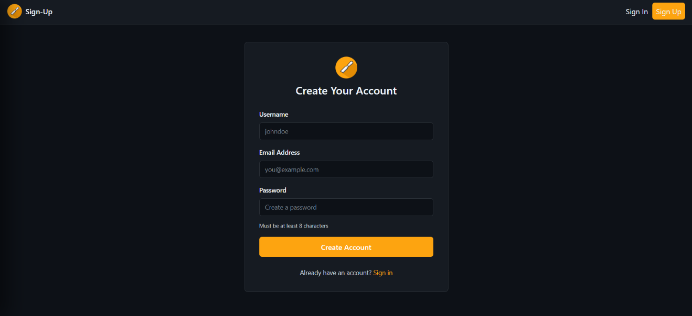
Sign Up page: shows the user the multiple fields needed to create an account, which will be stored in the database, while also giving the option to sign in instead if an account already exists.
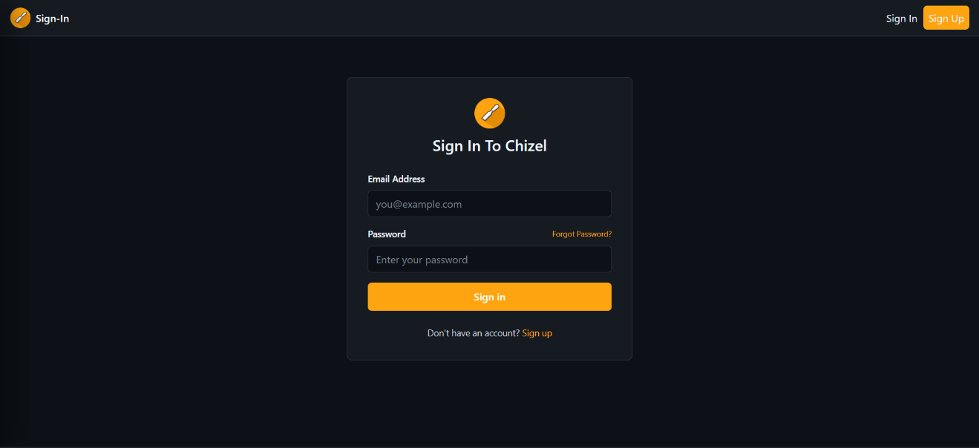
Sign In page: prompts the user to enter valid credentials that are verified in the backend with JWT, while also allowing the user to reset their password and sign up if they don’t have an account.
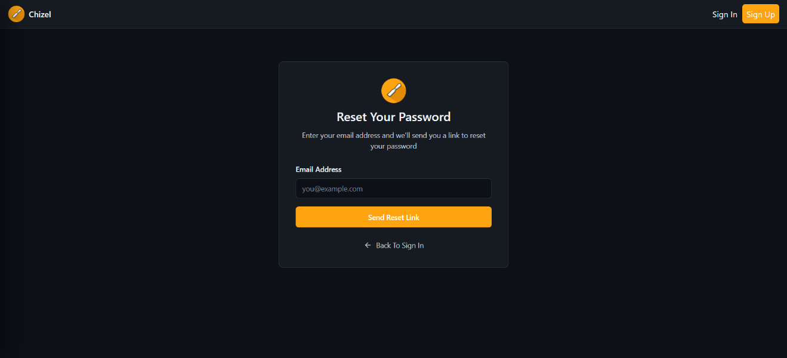
Forgot Password page: prompts the user to enter an email to reset the password of the account tied to it, this features doesn’t work as of now due to time constraints, the page also allows the user to go back to the sign in page.
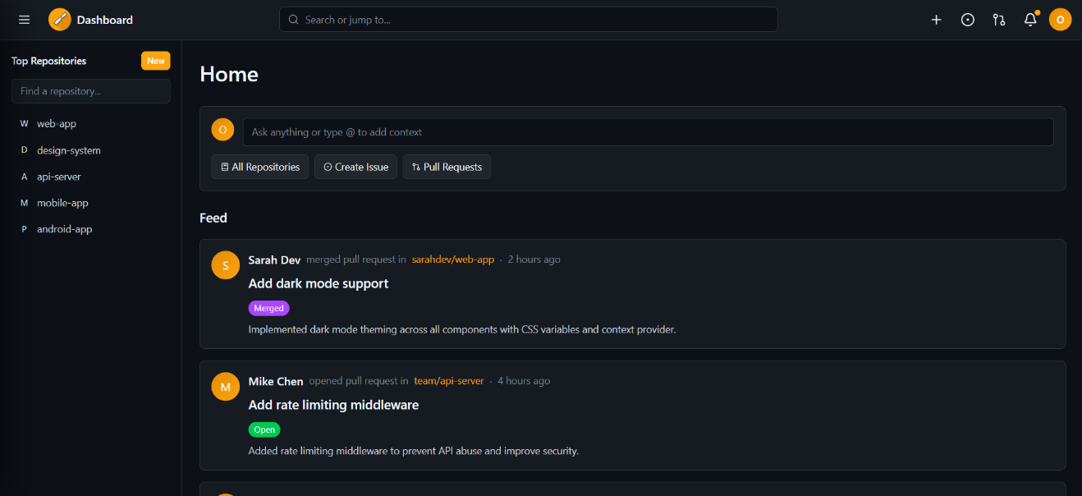
Home page: now that the user is logged in, they get access to the features of Chizel, the home page is equipped with a repository sidebar, that shows the user’s repositories where they engage in the most, while also showing them a feed of activities that are happening with their followings. Above it exist a space where the user can publish a comment to his feed (doesn’t work due to time constraints), a button to take them to the Repositories page, a button to take them to the Issues page and another for the Pull Requests page.
All of the pages have the same thing in common, the header, which gives the user access to multiple features, to the right you can see 5 buttons, the plus takes the user to their repository page, the circle takes them to the issues page, the pull requests takes them to its page, the bell takes them to the notifications page, in the middle exists a search bar (doesn’t work due to time constraints), and on the left is the logo of the app which returns the user to the home page upon clicking it, but a side bar also exists for navigation purposes.
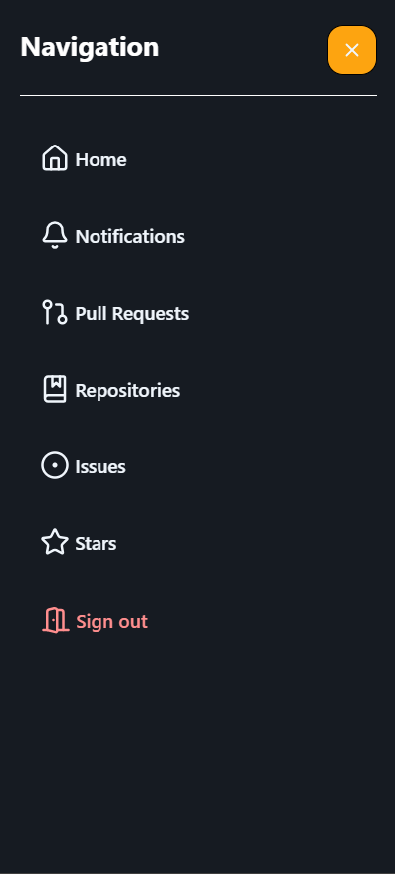
The sidebar is always accessible, with 2 extra options to go to the stars page and to sign out.
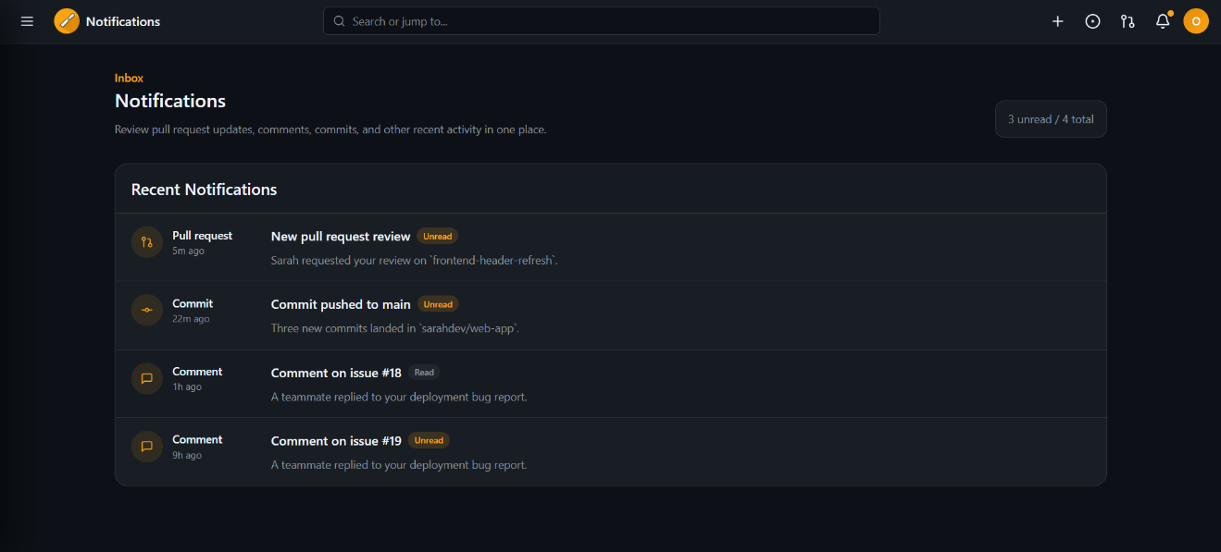
Notifications page: allows the user to receive notifications about certain activity that happens in his repositories, where the notification item can also redirect the user to the actual activity place.
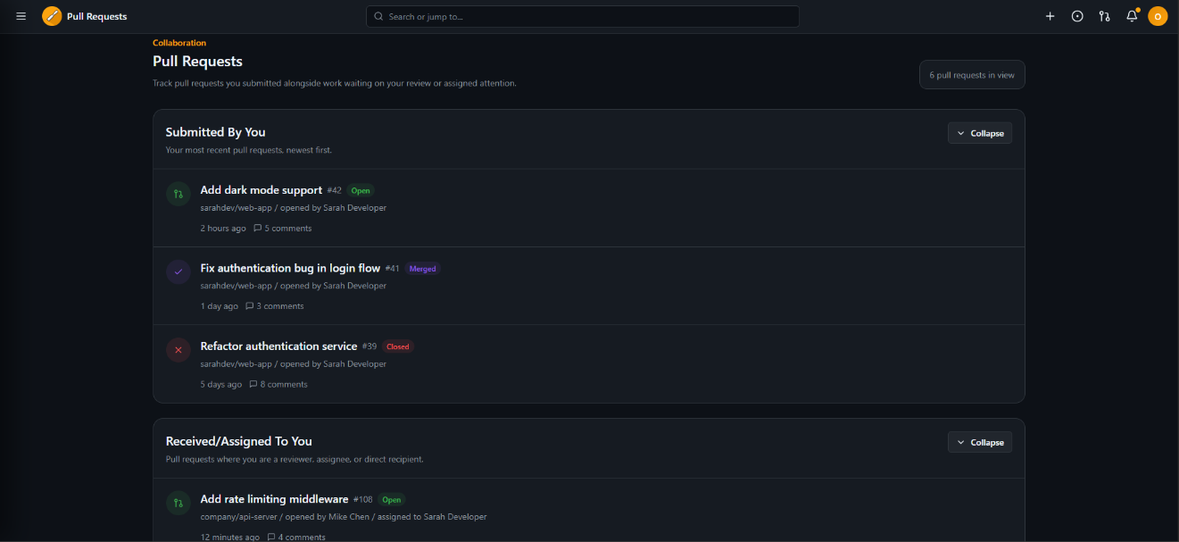
Pull Requests page: allows the user to see the pull requests that are submitted by them or assigned to them in 2 separate lists that can collapse and extend, the items can also redirect the user to the pull request itself.
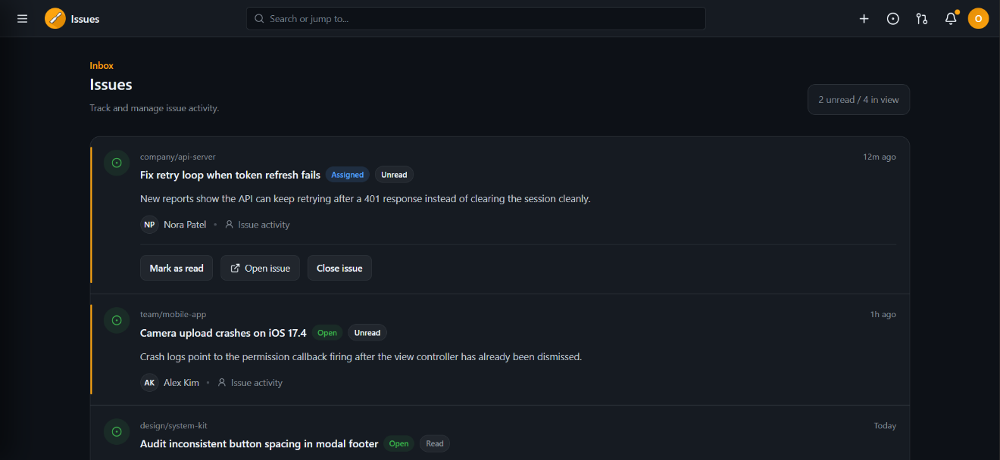
Issues page: allows the user to see the issues related to him, the items can also redirect the user to the issue itself.
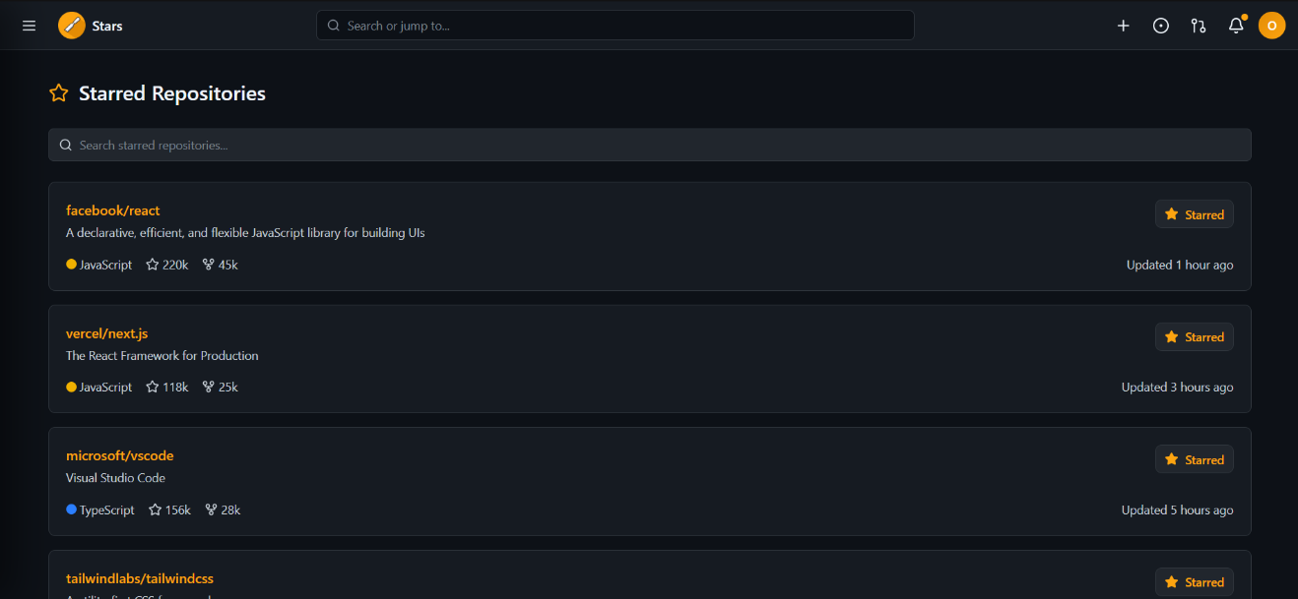
Stars page: allows the user to see the repositories he starred, and gives him the ability to visit these repositories and un-star them and remove them from the list.
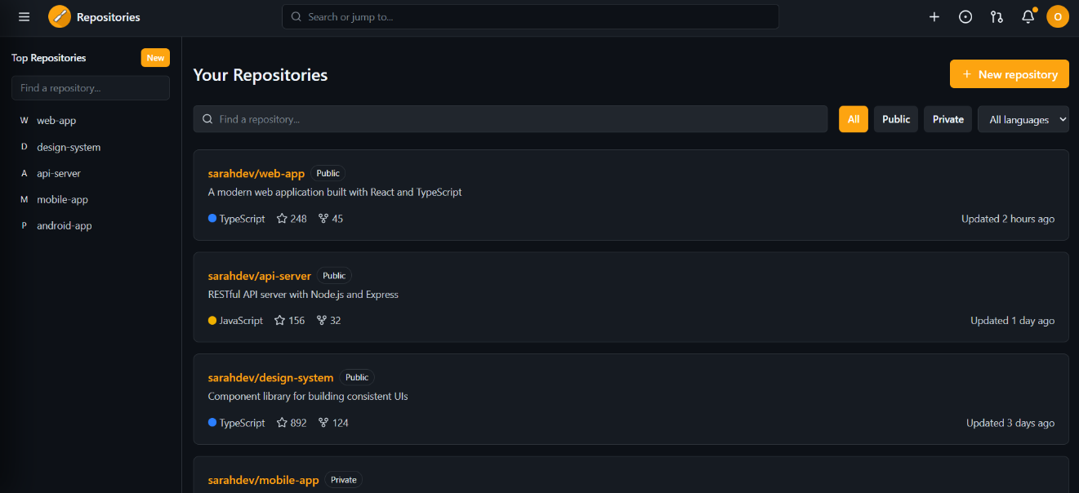
Repositories page: shows the user the repositories they are part of, with a working filter, the ability to create a new repository (doesn’t work due to time constraints) and most importantly enter a repository.
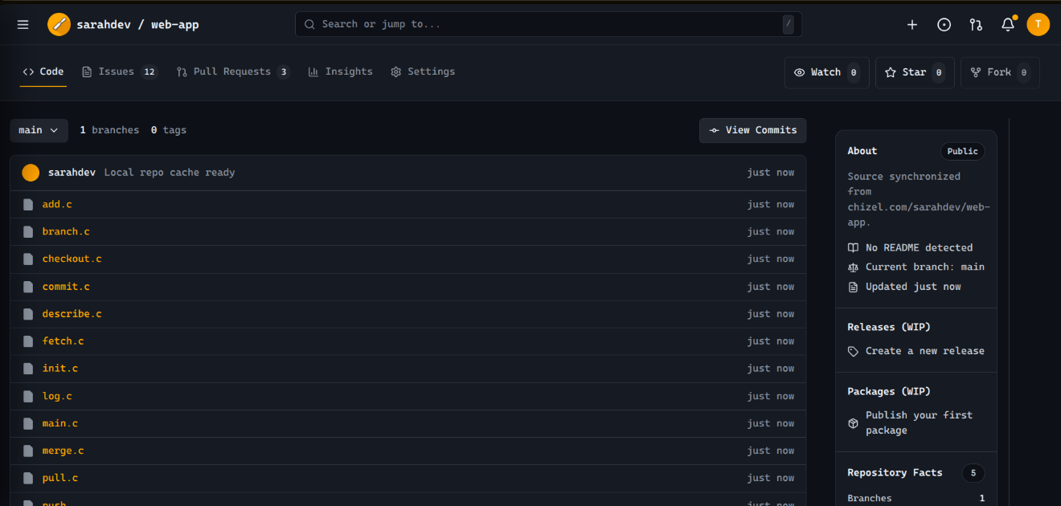
Repository page: a fully functional file explorer and reader, allows the user to access the files in their remote repository, equipped with an about, packages and releases (doesn’t work due to time constraints), contributors and language distribution.
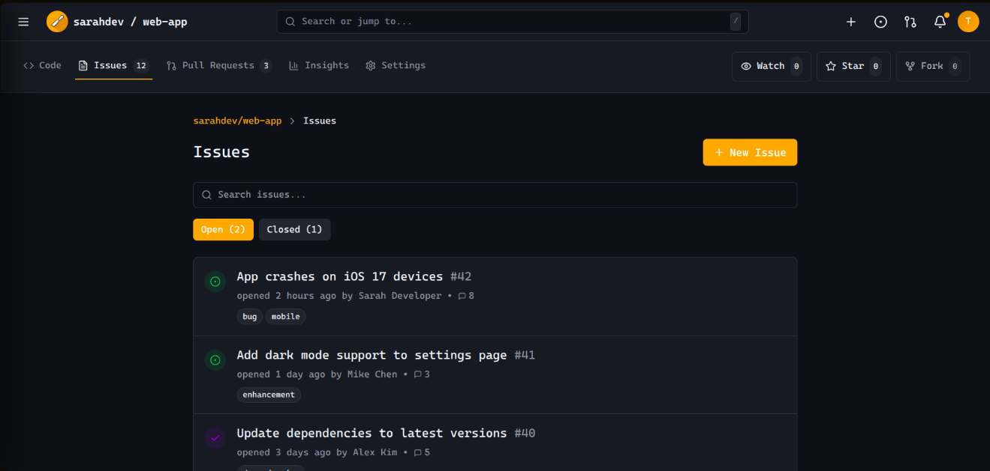
Repository Issues page: shows the issues within the repository.
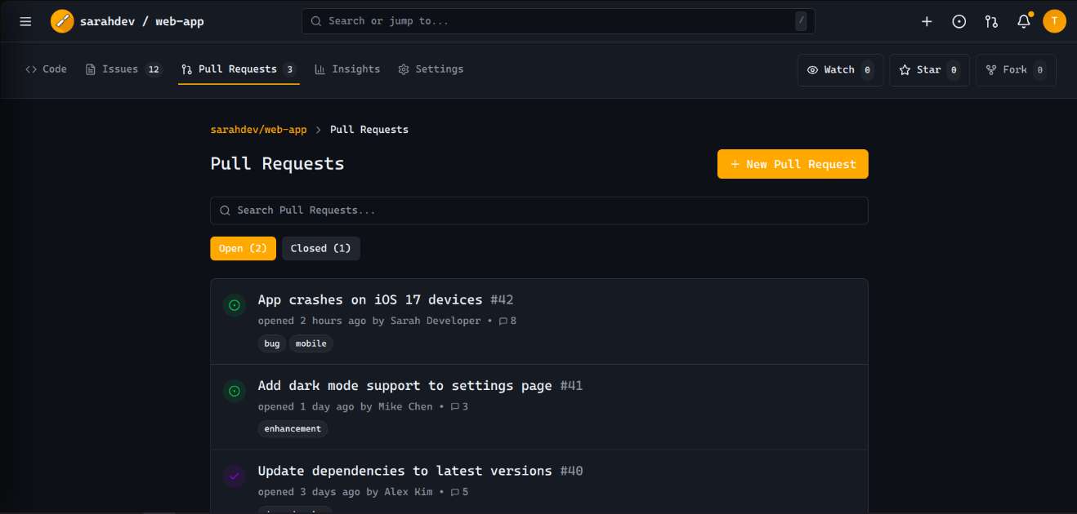
Repository Pull Requests page: shows the pull request within the repository.
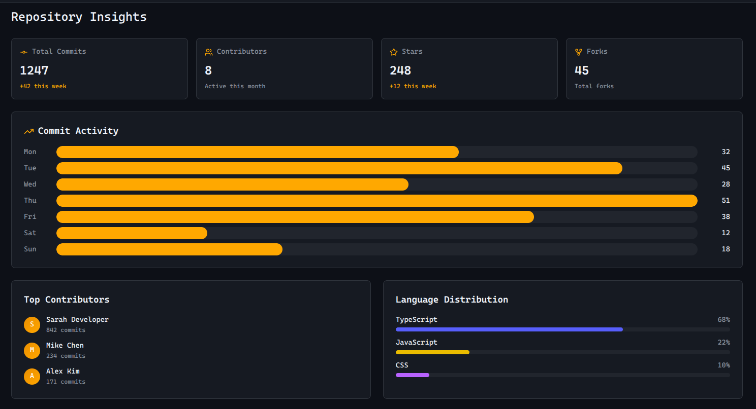
Repository Insights page: shows the statistics of the repository.
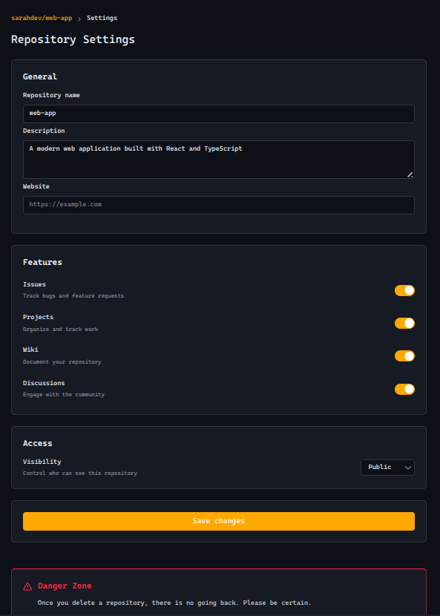
Repository Settings page: allows the owner to manipulate properties of the repository or fully delete it.

The dropdown menu appears when the user clicks on the profile button.
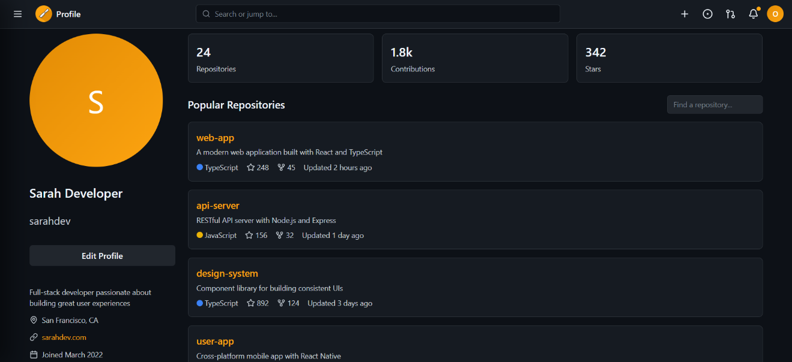
Profile page: show the user’s profile and the ability to edit it, his repositories will be shown as long as they are public, and their total activity on the website.
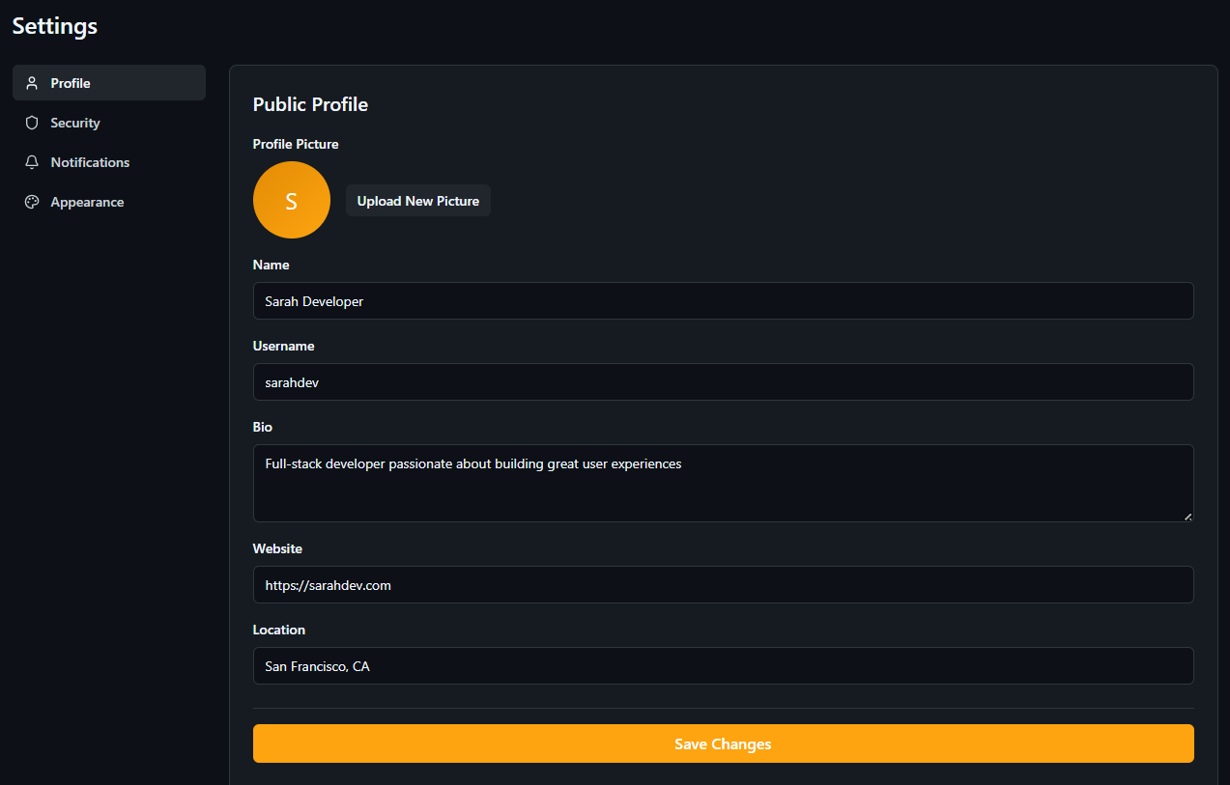
Profile Settings page: allows the user to edit multiple fields of their profile and save them where the values would be stored in the database.
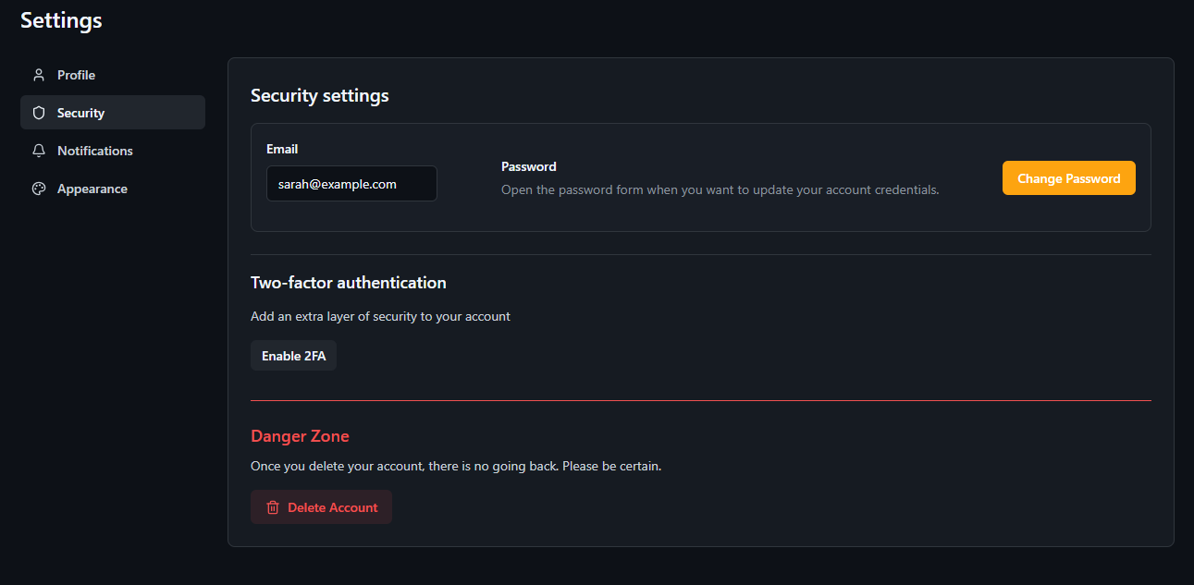
Security Settings page: allows the user to change his email, password and enable 2 factor authentication, while also allowing them to delete the account permanently, the only feature to work due to time constraints.
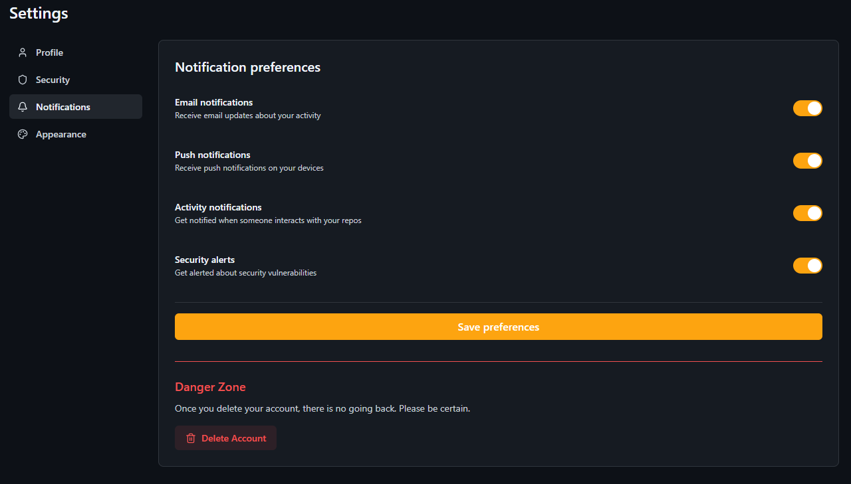
Notifications Settings page: allows the user to filter out unwanted notifications, doesn’t work due to time constraints.
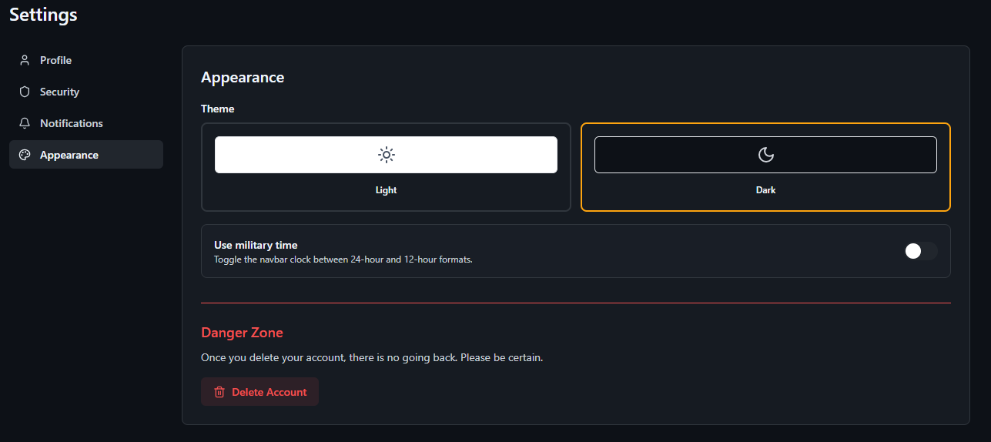
Appearance Settings page: allows the user to change the appearance of the website, doesn’t work due to time constraints.

Backend
The backend is designed to securely expose the core C engine to an authenticated client. It relies on a Node.js/Express middle-layer to manage the HTTP lifecycle, handle token-based authentication, and spawn the needed C binaries.
- C engine:
Because the engine is a compiled binary, it does not natively understand HTTP or web sessions. The backend server acts as a bridge, utilizing the OS-level spawn command to trigger the C executable. It passes sanitized arguments (such as commit hashes, file paths, or commands) into the process and streams the stdout/stderr back to the client. This isolation ensures the core engine remains focused entirely on systems-level memory and file management without being bloated by networking logic.
- Authentication Guard:
The authGuard is an Express middleware layer that sits between the incoming HTTP request and the protected routes that trigger the C engine. Before any Git command or repository-modifying route is executed, the request must pass through this guard.
Execution Flow:
+ The guard intercepts the incoming request and inspects the Authorization header.
+ It checks for the Bearer <token> format. If missing or malformed, it immediately rejects the request with a 401 Unauthorized.
+ It verifies the token's signature using the server's secret key.
+ If the token is valid, it decodes the payload, attaches the user context to the req object, and calls next() to proceed to the engine execution. If expired or invalid, it returns a 403 Forbidden.
- Axios interceptor:
To ensure a seamless user experience, the frontend utilizes an Axios Interceptor. Instead of manually attaching the JWT to every single API call made to the backend, the interceptor acts as a global middleware for all outgoing HTTP requests. Before a request leaves the client, the interceptor retrieves the stored JWT (typically from local Storage or memory) and injects it into the Authorization header. It also standardizes error handling, catching 401 responses globally to trigger an automatic logout or token refresh flow if the session expires while the user is actively working.
- JWT:
JWT serves as the foundation for stateless session persistence. Upon a successful login (a public route), the server signs a payload containing the user's identifying information and permission scopes, returning a signed token. Because the backend does not store session states in memory or a database, the JWT itself acts as the definitive proof of identity. The token is cryptographically signed, preventing the client from tampering with their permission levels.

Tasks distribution
The tasks have been distributed evenly among the contributors, Patrick worked on parts of branch and merge, finished tag and is working on status and checkout. Charbel worked on commit, while also collaborating with Omar on making init, branch and merge, who is also working on push, pull and log. Bilal worked on fetch, clone and add.
For the interface, Bilal works primarily on the front-end, Omar works on the database whilst Patrick and Charbel work together on the back-end. (webapp work isn’t fixed and is flexible)
The project also has a remote repository on GitHub, and Dr. Bernadette has access to the repository.

Conclusion
We’ve done great so far, managing to complete the important commands in chz, them being init, branch, merge, fetch, add, commit, clone and tag. We’ve also set up the connections between the back-end and the front-end using <BULL ANSWER THIS>, and fully setting up our database using Supabase.
As stated before in this report, we’re limited to time and energy, for that we’re humans after all, and the burn out is hitting hard, the overwhelming amount of course work that we’re behind on because of the big number of projects to be done, we can’t pour the time and energy needed to make this project in its entirety, for that some features had to be scrapped, like grep and describe.
Hopefully in the future we can still continue on this project, with the help of the community who also share a similar goal to our objective, from making it better and faster to adding more and more features. Maybe one day, it’ll overthrow GitHub?

Appendix
Extra documentation, figures are explained under them.
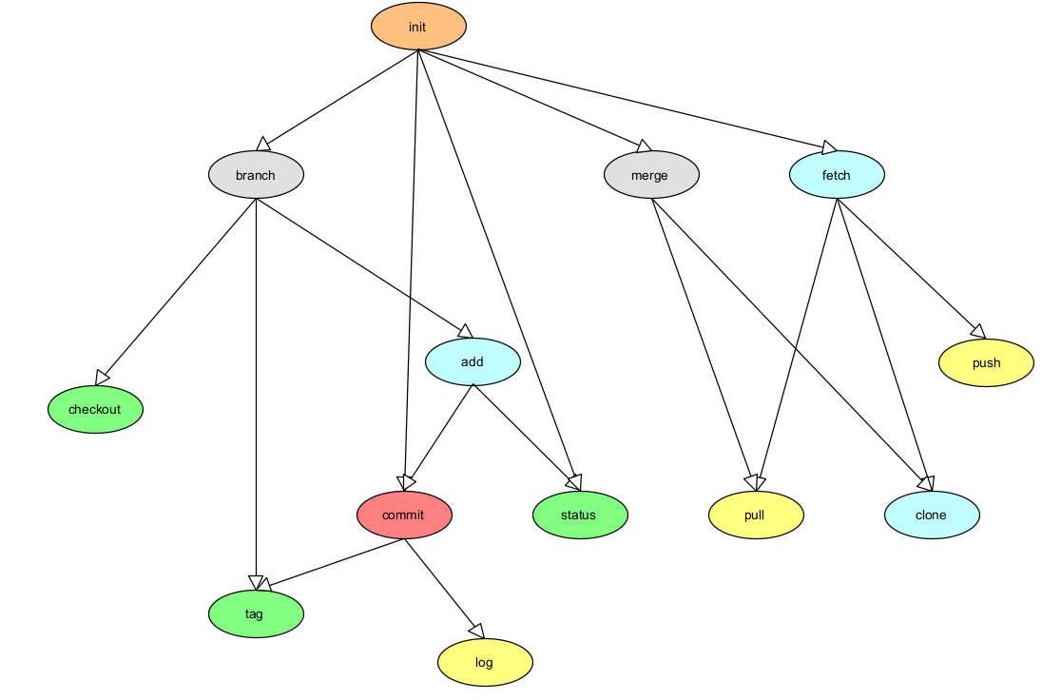
4.1: Tree Diagram showcasing the hierarchy and the road for the commands, higher levels means higher priority, as lower levels depend on them.
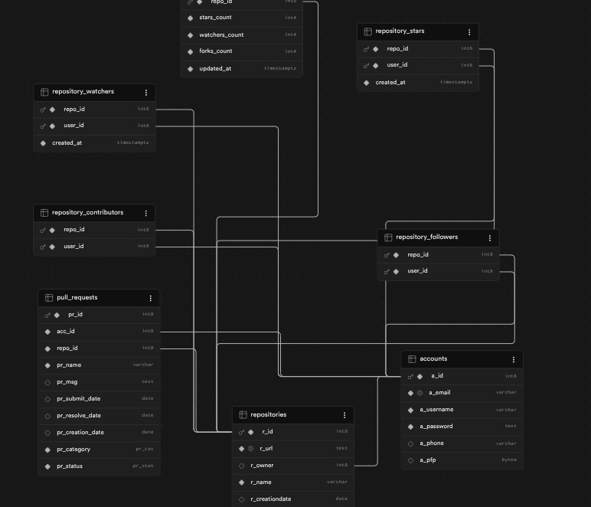
4.2: The database was a relatively exhausting system to implement, especially with the amount of times it has been redone from scratch. Initially, we decided on using MongoDB as our Query Language paired with MongoDB Atlas as our database, but that decision later stabbed us in the back with the newly imposed limits and the very slow execution speed that was apparent when the code fully implemented MongoDB uploading & restoration. After various efforts of trying to optimize and speed up the process, it proved inefficient for our course of action, so we moved to the good reliable SQL and Query Language, specifically PostgreSQL, as its features are what aligned most with our project, and its simplicity to implement proved superior than MySQL and OracleSQL.
The database, including tables, data & code implementation, was recreated from scratch again after the big refactor, as initially, the database held redundant tables and the code was unnecessarily bloated. For the last time, the database aspect was also slightly refactored after we concluded that a blob pack was our current best option to store data. All database efforts have been single-handily done by Omar.
Sequence Diagrams:
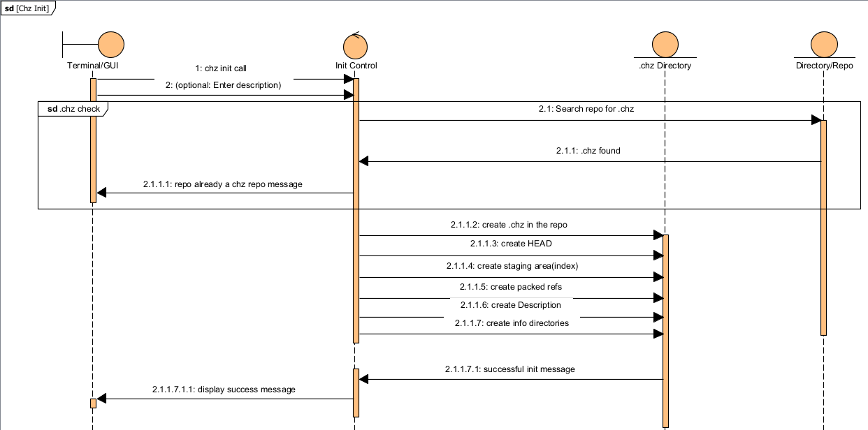
5.1: Init Sequence Diagram
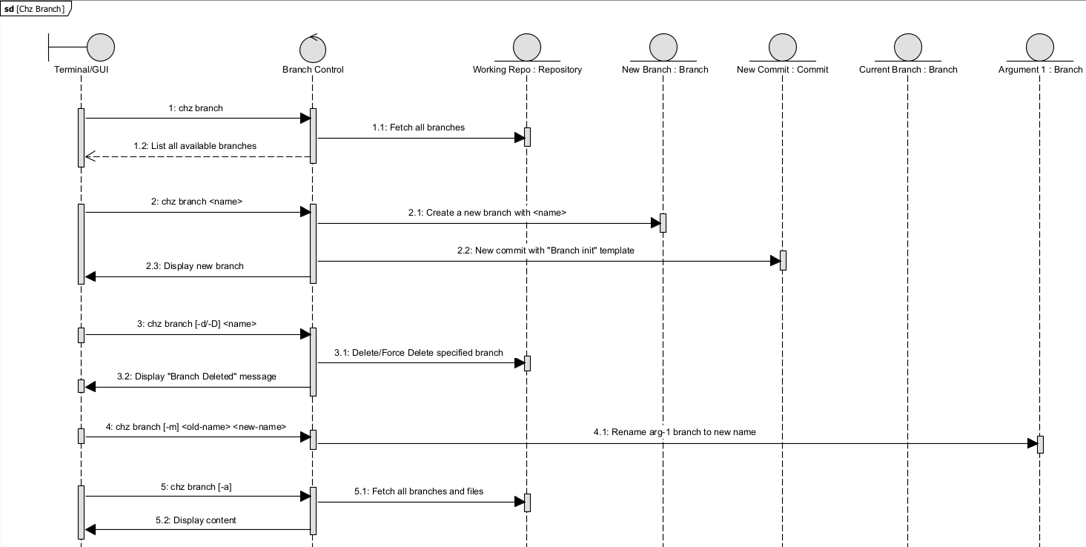
5.2: Branch Sequence Diagram
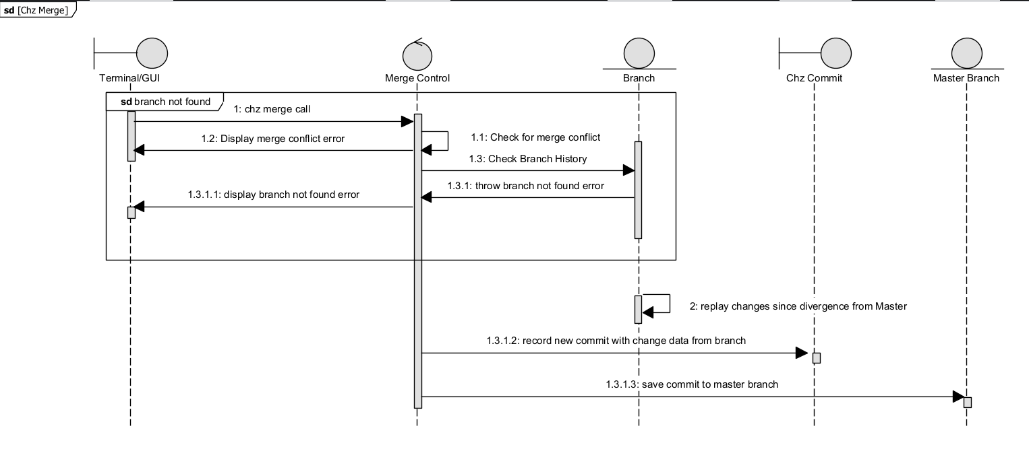
5.3: Merge Sequence Diagram
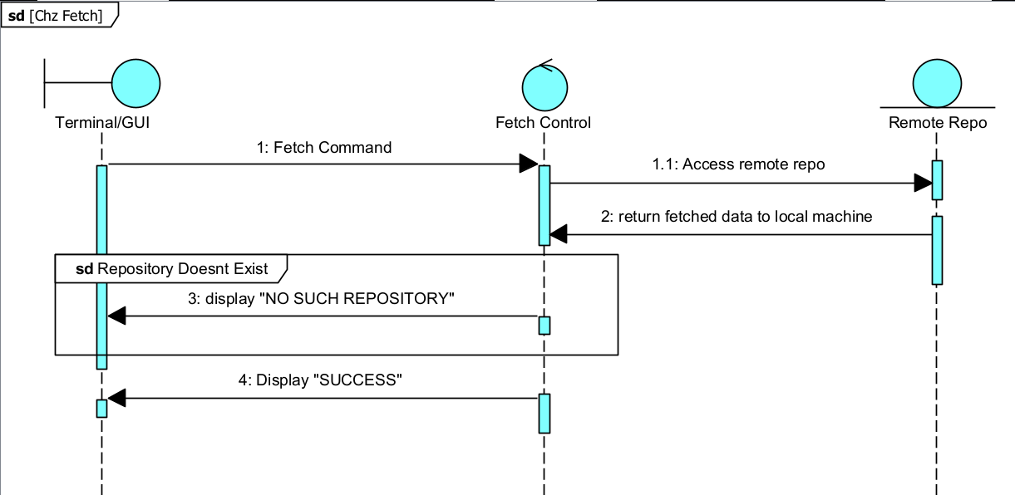
5.4: Fetch Sequence Diagram
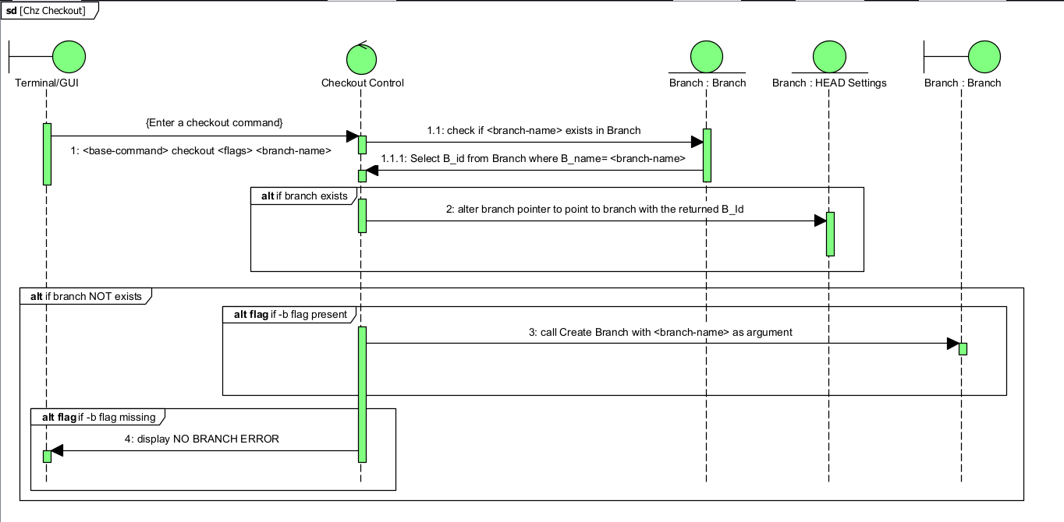
5.5: Checkout Sequence Diagram
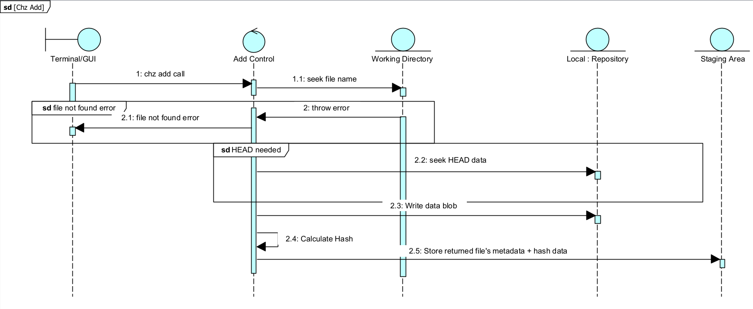
5.6: Add Sequence Diagram
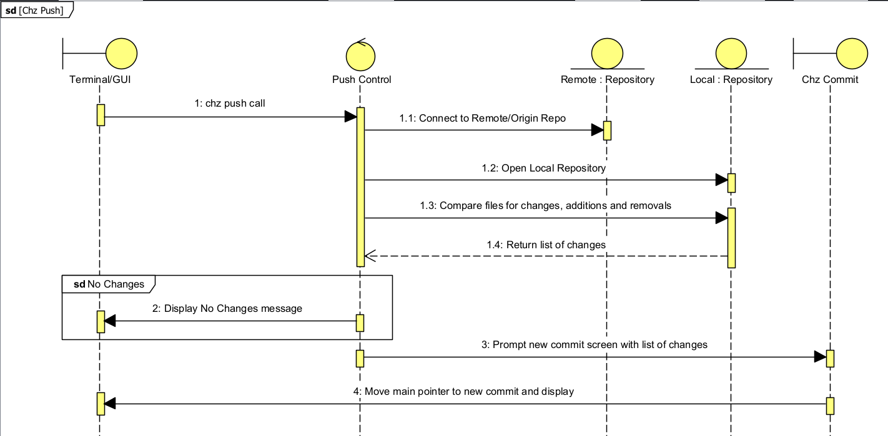5.7: Push Sequence Diagram
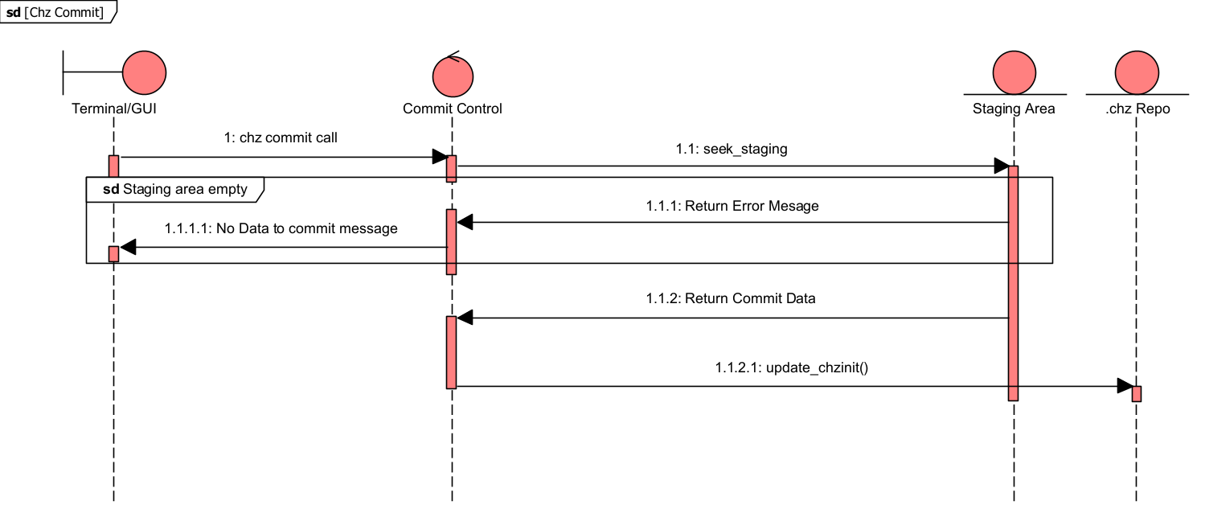
5.8: Commit Sequence Diagram
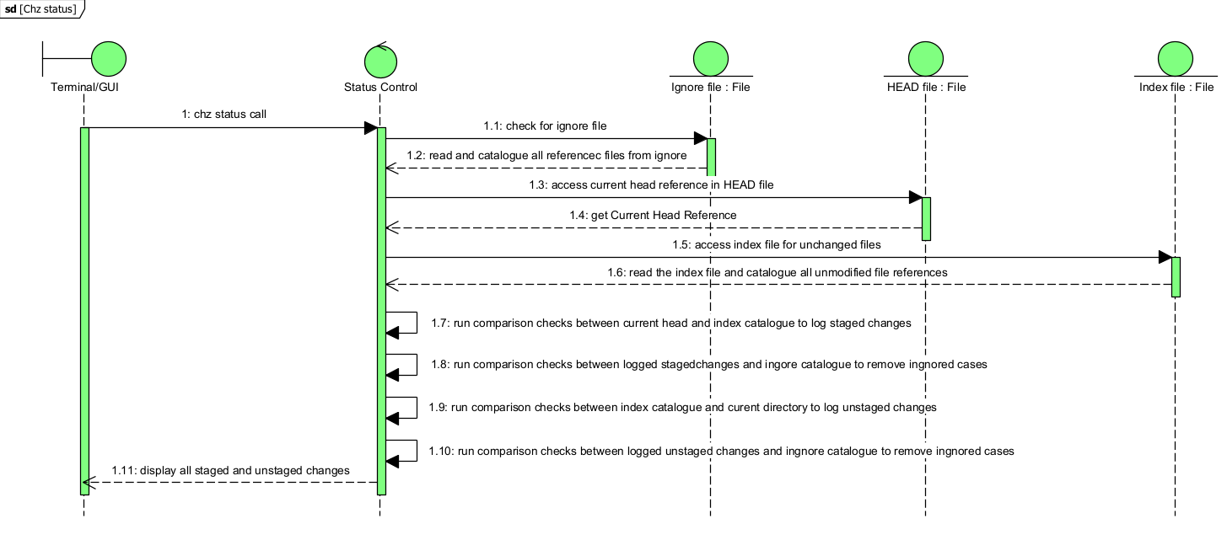
5.9: Status Sequence Diagram
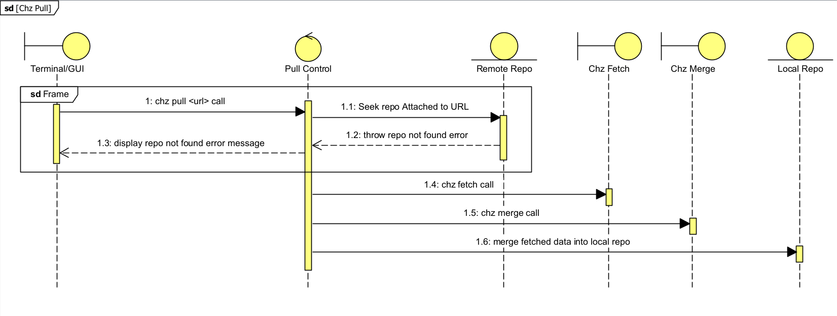
5.10: Pull Sequence Diagram
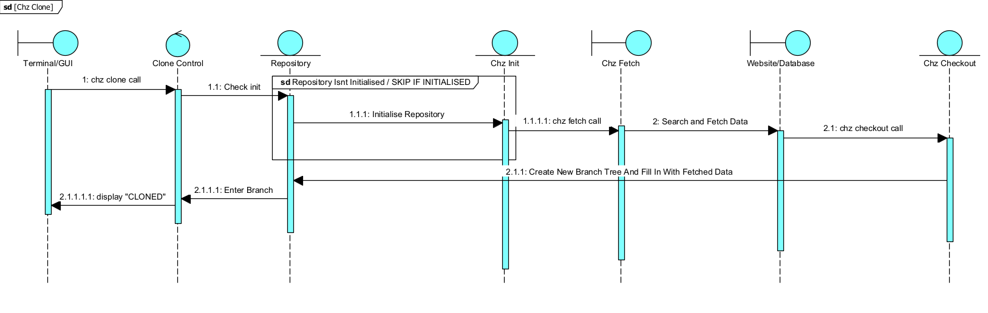
5.11: Clone Sequence Diagram
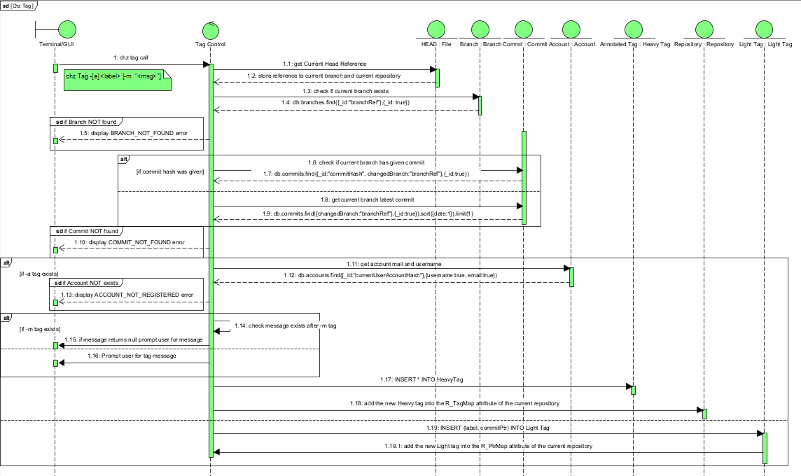
5.12: Tag Sequence Diagram
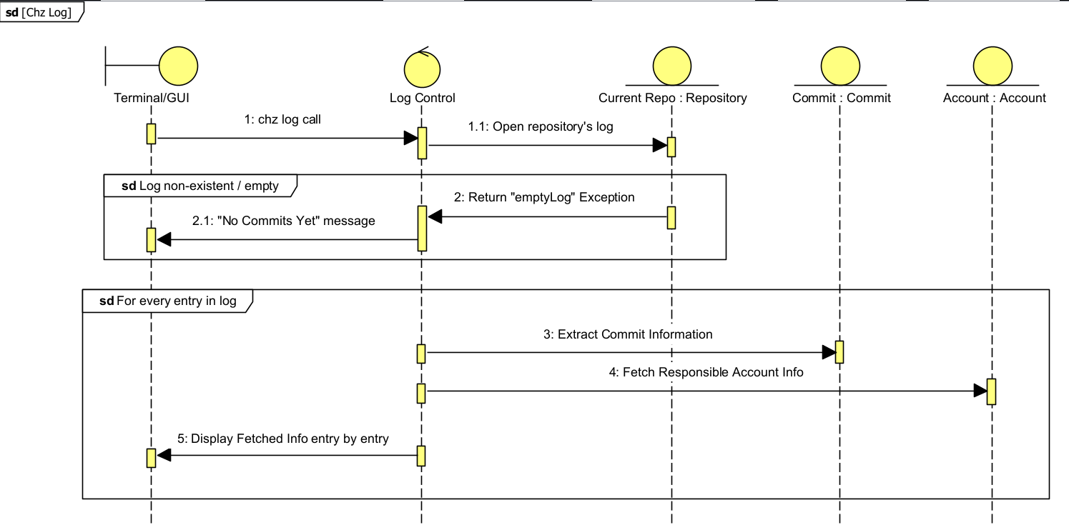
5.13: Log Sequence Diagram

